FruTea — Instant Fruit-Tea Powder
Section 12: Supply Chain Management Plan | Section 14: Operations Plan
Prepared by: Mahera | Appendix D | Report Parts 12, 14 | MGT368 | Version 7

Table of Contents

12. Supply Chain Management Plan

12.0 Basis of Analysis — Master Data Set, Benchmarks and Methodology
Single source of data. Every number, table and figure in Sections 12 and 14 is drawn from the accompanying master workbook “FruTea_Master_Data_SCM_Operations.xlsx”, which holds each category of data on a separate sheet (assumptions, ingredients/BOM, demand, suppliers, inventory, ABC, forecast, location, capacity, cost, stability, KPIs, risks, contingency and equations). The data tables and charts reproduced here are extracts from that workbook, keeping the whole analysis internally consistent and auditable.
This plan follows the design logic of established supply-chain and operations scholarship, in which supply-chain decisions are framed as a trade-off between responsiveness and efficiency and are grounded in quantitative models rather than intuition (Chopra & Meindl, 2019; Heizer et al., 2020). Every figure used below is drawn from one internally consistent Year-1 data set so that the sourcing, inventory, forecasting, location and operations calculations reconcile with one another. Where market values are quoted, they are benchmarked against comparable instant powdered-beverage products (Nestea, Lipton Ice Tea powder, Tang) and leading Bangladeshi FMCG operators (PRAN-RFL, ACI, Ispahani), then scaled down to a realistic first-year startup volume. All monetary values are illustrative planning assumptions in Bangladeshi Taka (Tk) and should be reconciled with the Finance section before submission.
Parameter | Value (Year-1 avg.) | Basis / benchmark & source
Monthly finished-goods output (Q) | 5,000 kg powder (5 tonnes) | Modest launch scale; ~333,000 cups/month at 15 g/serving
Annual output | 60,000 kg | Q x 12
3-year growth path | 5 -> 9 -> 15 t/month | ~3x in 3 years, consistent with early-stage FMCG scale-up (Chopra & Meindl, 2019)
Blend composition (by wt.) | Sugar 62%, Tea extract 12%, Maltodextrin 8%, others 18% | Typical instant iced-tea powder formulation (Codex Alimentarius Commission, 2020)
Target service level | 95% (Z = 1.65) | Standard for off-shelf FMCG staples (Heizer et al., 2020)
Shelf life | 12 months | Dry hygroscopic powder in barrier sachet
Demand concentration | ~80% Dhaka / 20% regional | Urban-youth, campus and super-shop focus; Dhaka is the dominant BD retail market
Holding-cost rate (H) | 25% of item value / year | Common FMCG carrying-cost benchmark (Chopra & Meindl, 2019)

Industry benchmark note. Bangladesh is among the world's largest tea-consuming and tea-producing nations, giving strong cultural demand for tea-based drinks (Bangladesh Tea Board, 2022), while the global ready-to-drink and instant-tea category continues double-digit growth driven by convenience and flavour innovation (Mordor Intelligence, 2023; Statista, 2023). FruTea is positioned at the intersection of these two trends: familiar tea taste delivered with the convenience of an instant fruit powder.
Derived monthly ingredient usage (blend x 5,000 kg): Sugar 3,100 kg; Tea extract 600 kg; Maltodextrin 400 kg; Citric/malic acid 150 kg; Fruit powder 175 kg; Flavour 75 kg. Annualised, these values feed every sourcing and inventory calculation in this section.
Ingredient | Annual demand (kg) | Unit price (Tk/kg) | Annual spend (Tk)
Tea extract (spray-dried) | 7,200 | 900 | 6,480,000
Sugar | 37,200 | 120 | 4,464,000
Flavour concentrate | 900 | 2,500 | 2,250,000
Fruit powder | 2,100 | 900 | 1,890,000
Maltodextrin | 4,800 | 150 | 720,000
Citric/malic acid | 1,800 | 180 | 324,000
Total | — | — | 16,128,000

12.0.1 Bottom-up validation of the 5-tonne planning volume
The 5 t/month figure is not assumed arbitrarily; it is built bottom-up from planned Year-1 channel coverage and a conservative reorder rate per outlet. Only a modest fraction of Dhaka's retail universe is penetrated in Year 1, which keeps the target realistic and defensible to an investor.
Channel | Active outlets (Yr 1) | Avg cups/outlet/week | Cups/week
Traditional retail & tea stalls | 1,300 | 32 | 41,600
Super shops (Shwapno, Meena, Agora) | 40 | 250 | 10,000
Universities & canteens | 25 | 400 | 10,000
Cafes & restaurants | 60 | 150 | 9,000
Offices & corporate | 30 | 120 | 3,600
E-/F-commerce | — | — | 4,000
Weekly total | — | — | 78,200

Monthly cups = 78,200 x 4.33 = ~338,600 -> round to ~333,000 cups/month (conservative)
Powder = 333,000 x 15 g = 4,995,000 g = ~5,000 kg = 5 tonnes/month (reconciles with 12.0)
Reading. The plan needs each retail outlet to sell only ~4-5 cups per day — a low bar for a Tk 20 impulse beverage — so the 5-tonne base is a floor, not a stretch. This is the demand anchor an investor needs before trusting the downstream logistics maths.

12.0.2 Cost and supply validation status (evidence plan)
All monetary inputs in this plan are indicative benchmarks. Before launch, each is to be replaced with a firm written quotation (RFQ) or letter of intent (LOI) from a named supplier, so that the model rests on real market prices rather than estimates. Validation status:
Input | Source of firm price | Validation status
Co-packer tolling & capacity | RFQ + LOI from 2 shortlisted co-packers | To be obtained pre-launch (see 12.4.2)
Sugar | RFQ from 2-3 local mills/refiners | Indicative benchmark used
Instant tea extract | RFQ from Sylhet processors + import quote | Indicative benchmark used
Fruit powder / flavour | CIF quotes from 2 certified exporters | Indicative benchmark used
Sachet barrier film | RFQ from Dhaka/Gazipur converters | Indicative benchmark used
Warehouse rent (Tejgaon) | Signed tenancy quote | To be confirmed on site selection
3PL / freight rates | Rate card from 2-3 carriers | Indicative benchmark used

12.0.3 Equations Used in This Plan (reference)
All quantitative decisions in Sections 12 and 14 apply the standard supply-chain and operations formulae below. Each is worked with FruTea data at the point of use; this table consolidates the notation.
# | Concept | Equation | FruTea result
1 | Economic Order Quantity | Q* = sqrt(2DS / H) | Sugar 1,929 kg
2 | EOQ total cost | TC = (D/Q)S + (Q/2)H ; TC* = sqrt(2DSH) | Tk 57,862/yr
3 | Reorder point | ROP = d x L + SS | Fruit powder 456 kg
4 | Safety stock (combined var.) | SS = Z x sqrt(L x sd^2 + d^2 x sL^2) | 134 kg @ 95%
5 | Cycle service level | Z at P(no st-out); 95% -> Z = 1.65 | Z = 1.65
6 | Inventory turnover | Turns = COGS / average inventory | 7.5 - 9.4x
7 | Days inventory outstanding | DIO = 365 / turns | ~39-49 days
8 | Little's Law | I = R x T (inventory = rate x flow time) | ~2,900 kg FG
9 | Economic Production Qty | Q*p = sqrt(2DS/H) x sqrt(1/(1 - d/p)) | own line, Yr 2
10 | Centre of gravity | Cx = Sum(wi xi)/Sum(wi) | (107.5, 97.8)
11 | Exponential smoothing | F(t+1) = a A(t) + (1-a) F(t) | a = 0.3
12 | Forecast error (MAPE) | MAPE = (1/n) Sum |A-F|/A | 19.0%
13 | Capacity utilisation | U = throughput / capacity | 25-34% (co-pack)
14 | Cash-to-cash cycle | CCC = DIO + DSO - DPO | ~24-39 days
15 | Bullwhip ratio | BW = Var(orders) / Var(demand) | target ~1.0

12.1 Supply Chain Management Objectives
The supply chain is engineered to be asset-light yet scalable, so that a student-founded venture can launch on limited capital and still grow threefold within three years. Six measurable objectives govern every downstream decision:
- Availability: sustain a >=95% service level on fast-moving SKUs (Lemon and Mango single sachets), the two flavours expected to account for the majority of early volume.
- Cost efficiency: hold total landed supply-chain cost (sourcing + inbound + storage + outbound) at or below 18% of ex-factory price.
- Quality and food safety: guarantee full batch traceability and compliance with BSTI, the Bangladesh Food Safety Authority and HACCP principles (Codex Alimentarius Commission, 2020).
- Scalability: absorb a 3x volume increase without structural redesign — by adding co-packing shifts, then in-house lines.
- Supplier reliability: maintain dual sourcing on every critical input to remove single points of failure.
- Freshness: achieve a 7-10 day production-to-shelf cycle inside the 12-month shelf life.

12.2 Supply Chain Strategy and Methods Used (and why they fit FruTea)
A deliberate set of established methods is applied, each selected for a specific characteristic of an instant fruit-tea powder sold to price-sensitive urban consumers. The table names the method, where it is used, and the product-specific reason it is appropriate.
Method / framework | Applied to | Why it suits FruTea (tailored rationale)
Make-to-Stock (MTS) | Production & finished goods | A low-unit-value impulse/staple FMCG bought off the shelf; customers will not wait for a made-to-order batch, and the 12-month shelf life makes producing ahead of forecast low-risk (Heizer et al., 2020).
Push-Pull decoupling | Warehouse = decoupling point | Long-lead imported inputs are ordered on forecast (push); channel replenishment is triggered by actual sell-through (pull). The boundary sits at the Dhaka warehouse (Chopra & Meindl, 2019).
Hub-and-spoke distribution | Outbound network | ~80% of demand is in Dhaka, so one central hub feeding channel spokes minimises total distance (validated by centre-of-gravity in 14.1).
Asset-light outsourcing (3PL + contract mfg.) | Transport & Year-1 production | Converts fixed cost to variable cost and slashes launch capex for a capital-constrained founder.
EOQ + ROP + safety stock | Inventory control | Inputs differ sharply in value and lead time; formula-based ordering minimises total cost while protecting the 95% service level (Chopra & Meindl, 2019).
ABC analysis | Inventory prioritisation | A few inputs dominate spend; ABC focuses control where it pays (Jacobs & Chase, 2021).
FEFO | Warehouse issue rule | A dated food product must ship earliest-expiry first to protect freshness and avoid write-offs.
Kraljic portfolio matrix | Sourcing strategy | Classifies inputs by supply risk x profit impact so strategic imports and routine locals get the right approach (Kraljic, 1983).
Weighted-point supplier scoring | Supplier selection | Turns a multi-criteria choice into an objective, auditable score (Heizer et al., 2020).
Time-series forecasting + seasonal index | Demand planning | Captures the strong summer/festive seasonality of cold beverages plus the brand's growth trend (Heizer et al., 2020).
Centre-of-gravity model | Facility location | Yields a mathematical optimum for the warehouse against the demand map (Ballou, 2004).

End-to-end chain: Suppliers -> Contract manufacturer (co-packer) -> FruTea central warehouse (Dhaka) -> Distributors / direct channels -> End customers, with the push-pull decoupling point at the warehouse.
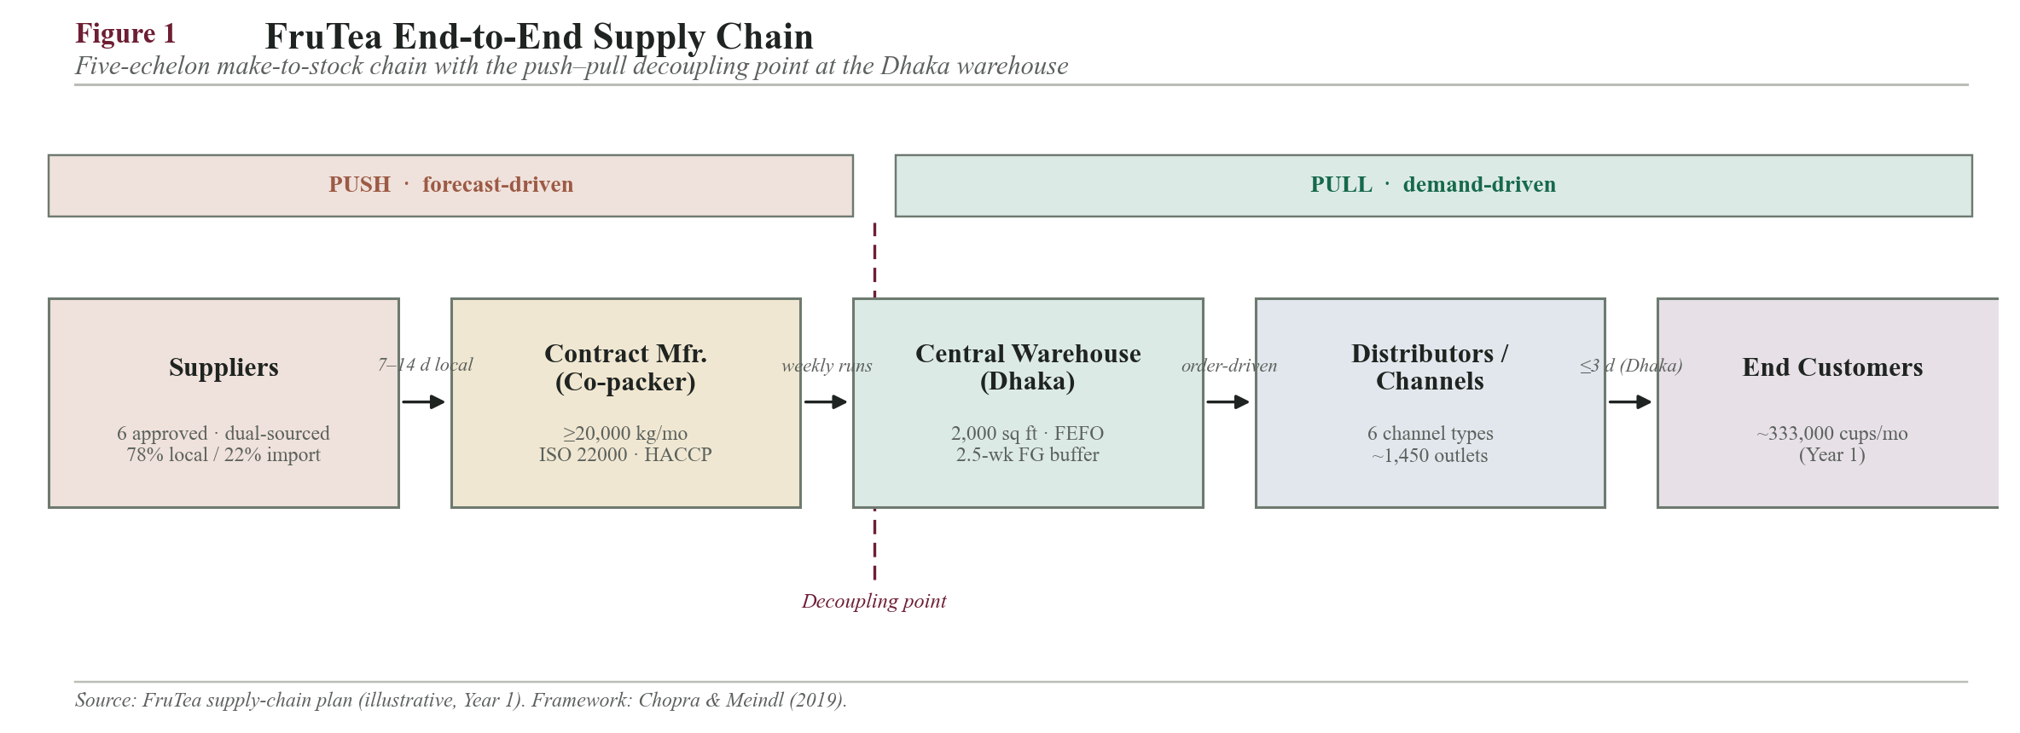
End-to-end SCM flow diagram with the push-pull decoupling point marked at the Dhaka warehouse
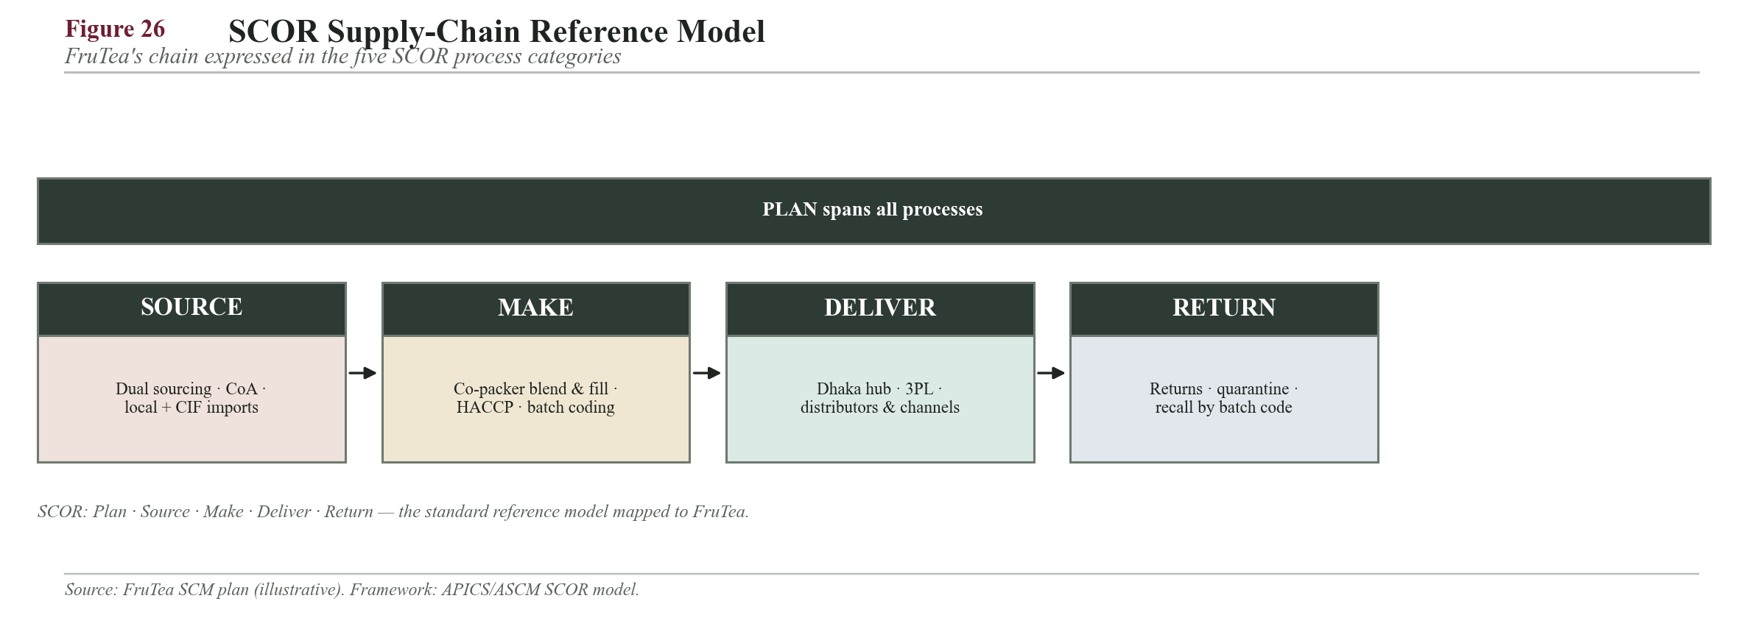
Figure 26. FruTea supply chain mapped to the SCOR reference model (Plan–Source–Make–Deliver–Return).
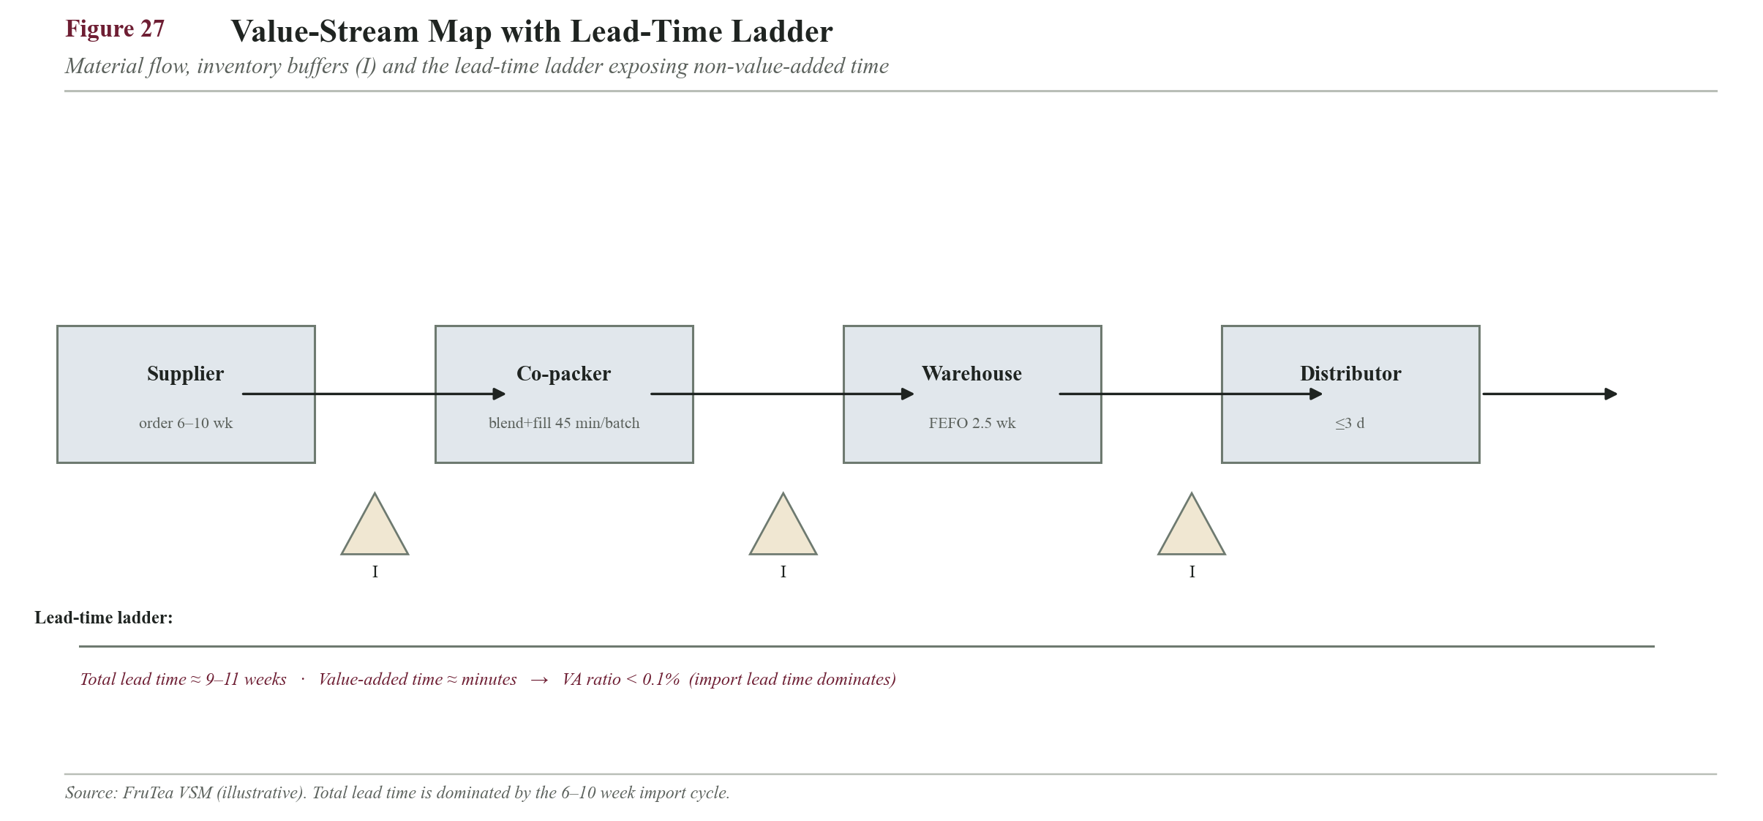
Figure 27. Value-stream map with lead-time ladder — total lead time is dominated by the 6–10 week import cycle.

12.3 Raw Material Sourcing
Because FruTea is a spray-dried instant powder rather than a brewed or bagged tea, its bill of materials mirrors that of instant iced-tea powders: a soluble tea base, a sweetening and bulking system, an acid-flavour system, and functional stabilisers, all dry-blended and filled into moisture-barrier sachets (Codex Alimentarius Commission, 2020). The composition below is expressed as a share of blend weight and drives the ingredient-usage figures in 12.0.
Raw material | Function in FruTea | % of blend | Sourcing
Instant tea extract | Tea base: colour, aroma, natural caffeine; instantly soluble | 8-15% | Local (Sylhet) + import backup
Sugar (sucrose/dextrose) | Primary sweetener + bulking agent | 55-70% | Local (BD mills)
Maltodextrin | Carrier / free-flow bulking; solubility & mouthfeel | 5-10% | Import
Citric/malic acid | Acidulant: the tangy fruity-tea note | 2-4% | Import
Fruit powder | Real-fruit character per flavour | 2-5% | Import
Flavouring (natural/nature-identical) | Reinforces and stabilises the fruit note | 0.5-2% | Import
Food colour | Flavour-matched visual appeal | <0.5% | Import
Ascorbic acid (Vit C) | Antioxidant + light nutrition claim | <0.5% | Import
Anti-caking agent | Prevents clumping in high humidity | <1% | Import
Sucralose/stevia | Enables the planned Year 2 Low-Sugar Green Tea line | replaces sugar | Import

Packaging materials: laminated barrier sachet film (PET/metallised/PE — the critical moisture and light barrier for a hygroscopic powder), printed mono-cartons, shipping cartons and batch-code labels, all sourced locally from Dhaka/Gazipur flexible-packaging converters.
Sourcing rationale (local + import split). Sugar, tea solids and all packaging are procured locally, which shortens lead times, removes duty and forex exposure, supports the brand's local-sourcing sustainability claim and generates domestic employment. Only the low-volume, high-value functional inputs (fruit powder, flavour, colour, acid, maltodextrin and specialty sweeteners) are imported, because they are not produced at food-grade scale in Bangladesh. Since sugar alone is 62% of blend weight, the great majority of raw-material weight and cost stays local while forex exposure is confined to under 20% of ingredient spend — a deliberate hedge against the taka's depreciation pressure (Bangladesh Bank, 2023).

12.3.1 Import lead-time breakdown (CIF, Incoterms 2020)
Imported inputs are bought on CIF Chattogram terms so the supplier bears freight and insurance to the port; FruTea's C&F agent then handles clearance. The door-to-door lead time — the reason imports are ordered on forecast and carry large safety stock — decomposes as follows:
Stage | Typical duration
Purchase order to supplier production ready | 1-2 weeks
Ocean transit (India/China/Thailand -> Chattogram) | 2-4 weeks
Port clearance + C&F documentation (LC, HS code, BSTI/BFSA) | 1-2 weeks
Chattogram -> Dhaka inland trucking (~250 km) | 2-3 days
Total door-to-door | 6-10 weeks

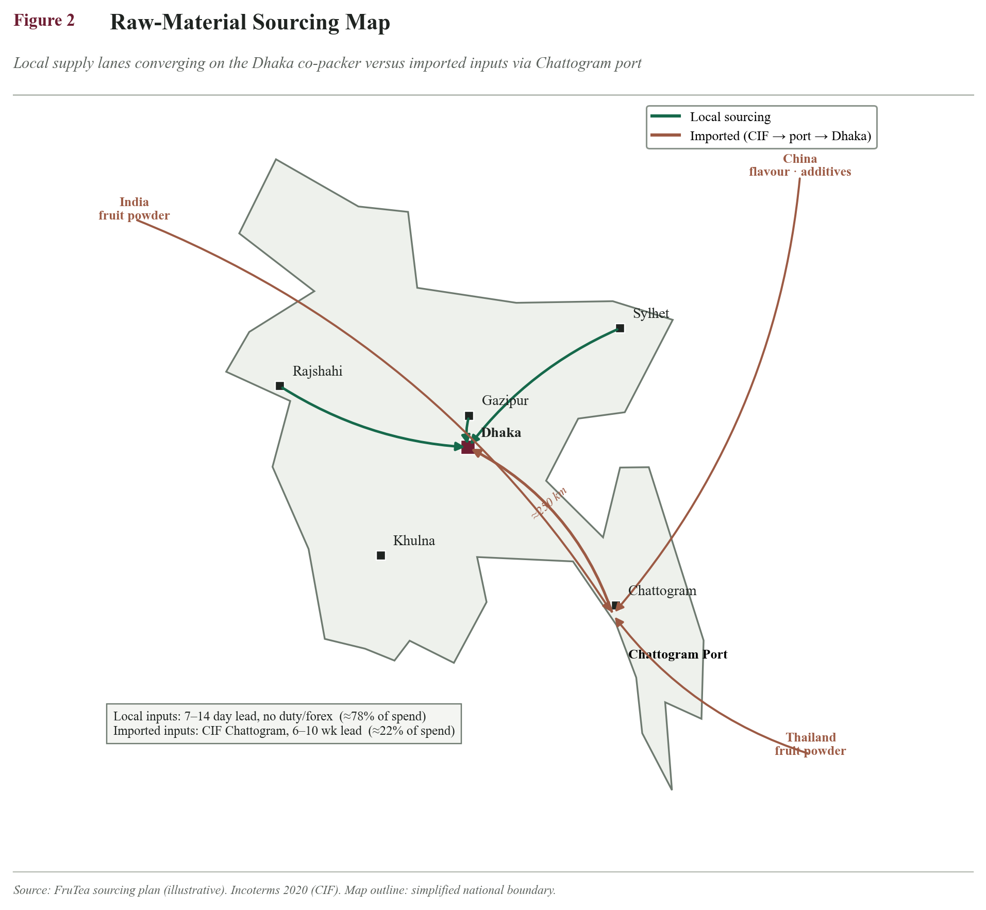
Sourcing map: local flows (Sylhet/Dhaka/Gazipur) vs import lanes (India/China/Thailand -> Chattogram port -> Dhaka)
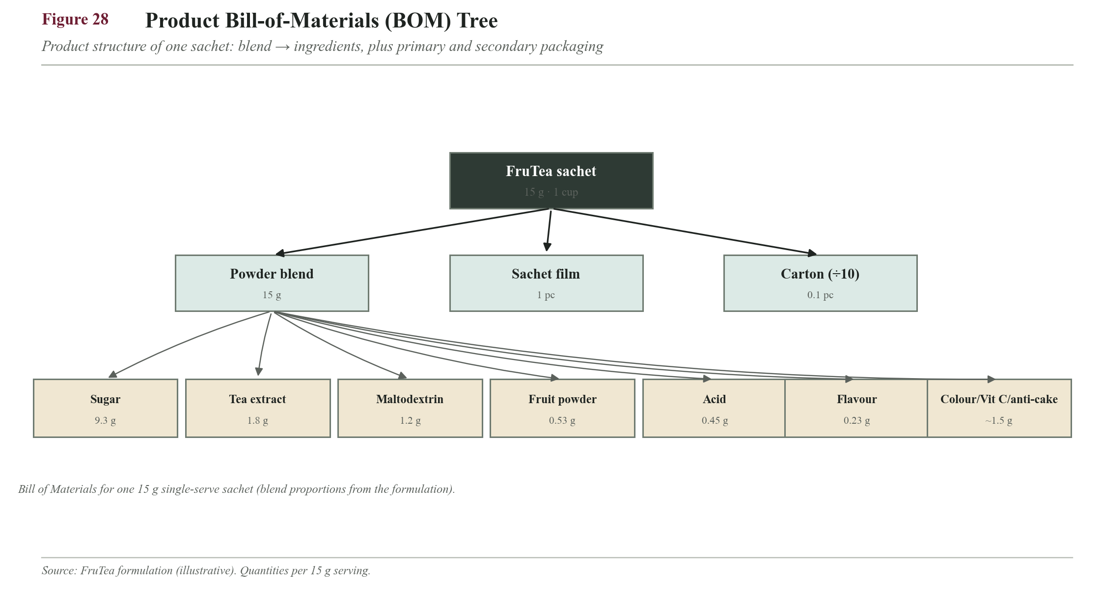
Figure 28. Bill-of-materials tree for one 15 g sachet (blend proportions and packaging).
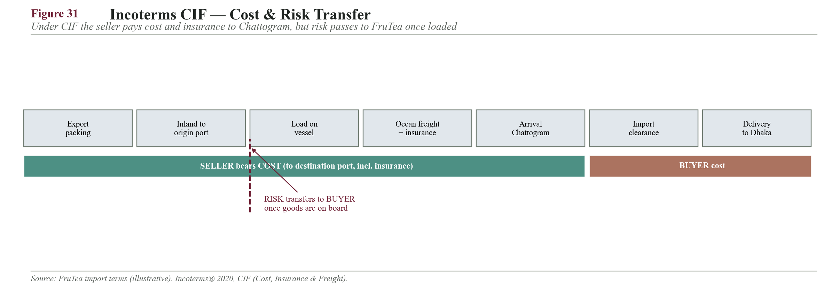
Figure 31. Incoterms CIF — the seller bears cost and insurance to Chattogram, but risk passes to FruTea once goods are loaded.

12.4 Supplier Selection — Weighted-Point Method (worked)
Supplier choice uses the weighted-point (factor-rating) method, in which each criterion carries a weight, each candidate is scored 1-5, and the weighted sum decides (Heizer et al., 2020). Weighted score = Sum(weight x score). The worked example below evaluates three tea-extract suppliers — tea extract being the single highest-spend input (12.6.3).
Criterion (weight) | A: Local Sylhet | B: Import India | C: Local small
Quality & certification (0.25) | 4 | 5 | 3
Price (0.20) | 5 | 3 | 4
Reliability / OTIF (0.20) | 4 | 4 | 3
Lead time & flexibility (0.15) | 5 | 2 | 4
MOQ suitability (0.10) | 4 | 3 | 5
Financial stability (0.05) | 3 | 5 | 2
Sustainability (0.05) | 5 | 3 | 4
Weighted total | 4.35 | 3.65 | 3.55

A = 4(.25)+5(.20)+4(.20)+5(.15)+4(.10)+3(.05)+5(.05) = 1.00+1.00+0.80+0.75+0.40+0.15+0.25 = 4.35
B = 5(.25)+3(.20)+4(.20)+2(.15)+3(.10)+5(.05)+3(.05) = 1.25+0.60+0.80+0.30+0.30+0.25+0.15 = 3.65
C = 3(.25)+4(.20)+3(.20)+4(.15)+5(.10)+2(.05)+4(.05) = 0.75+0.80+0.60+0.60+0.50+0.10+0.20 = 3.55
Decision. Supplier A (local Sylhet) is appointed primary at 4.35, winning on price, lead time and sustainability — the criteria that matter most for a cost-sensitive local product. Supplier B (import) is retained as the approved second source under a dual-sourcing policy because it scores highest on quality and financial stability, making it a dependable buffer against local supply shocks.
Kraljic classification (why sourcing differs by item). Applying Kraljic's (1983) supply-risk vs profit-impact logic: imported flavour and fruit powder are Strategic/Bottleneck items (high risk, hard to substitute) and are managed through dual sourcing, long-term relationships and buffer stock; sugar is a Leverage item (high spend, many suppliers) managed by competitive tendering; cartons and tape are Routine items managed by simple bulk ordering. This ensures scarce management attention is spent where supply risk is genuinely high.
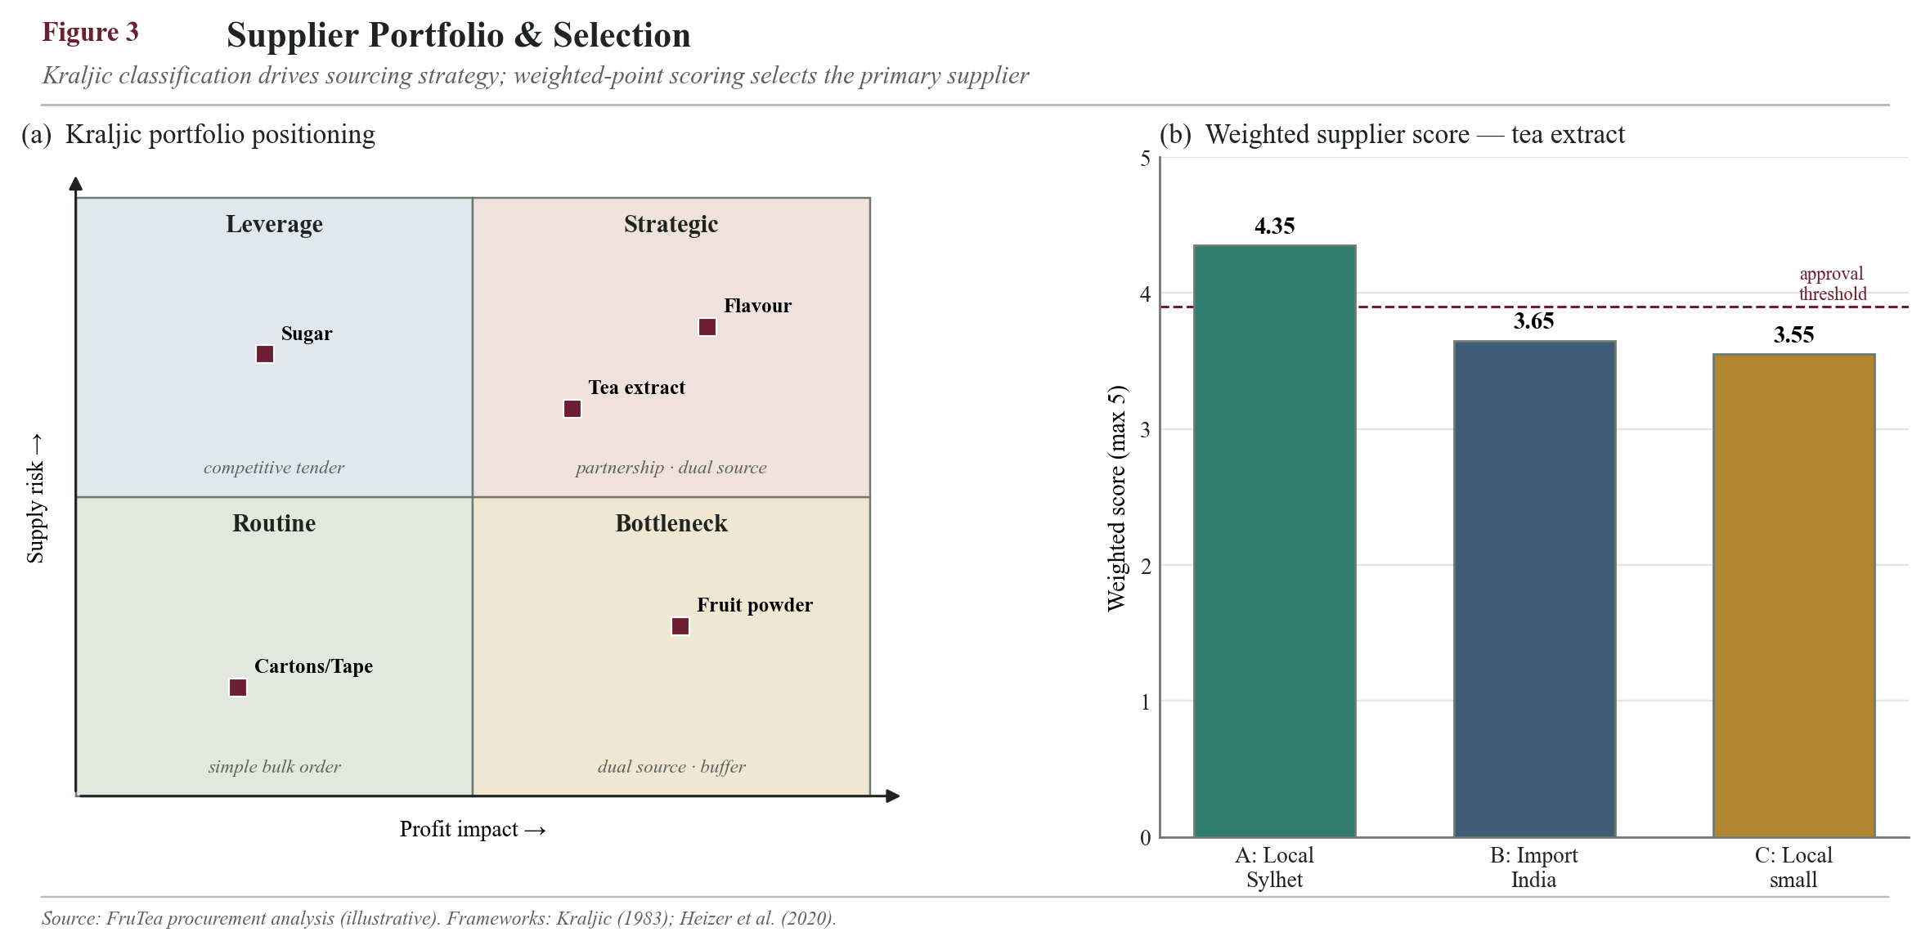
Kraljic matrix (supply-risk vs profit-impact) + supplier-score bar chart
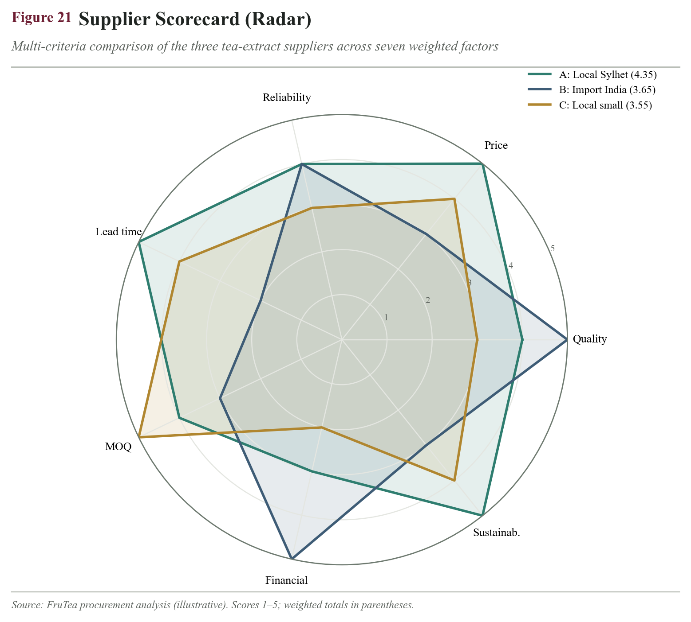
Figure 21. Supplier scorecard (radar) — Supplier A leads on price, lead time and sustainability.

12.4.2 Contract Manufacturer (Co-packer) Selection, Capacity and Terms
Because Year 1 depends entirely on a co-packer, the choice is treated as a primary make-or-break decision, not a footnote. Bangladesh has an established base of food and beverage contract manufacturers operating dry-blending and multi-lane sachet/stick-filling lines, several of which already toll-manufacture powdered drinks and instant mixes. FruTea qualifies at least two before committing, and secures a written LOI covering the terms below.
Co-packer requirement | Target / specification
Certification | ISO 22000 / HACCP + BSTI-registered facility
Capability | Food-grade dry blending + laminated sachet/stick filling (multi-lane)
Confirmed line capacity | >= 20,000 kg/month (so FruTea uses <35% even at peak)
Minimum order quantity (MOQ) | <= 250 kg per flavour batch (suits low-volume launch)
Changeover / cleaning time | <= 60 min between flavours (allergen/colour carry-over control)
Lead time (booking to finished goods) | <= 2 weeks per weekly run
Quality | Batch CoA + release testing to FruTea's 12.11 specs
Backup | A second qualified co-packer on standby (dual sourcing)
Tolling fee | Per-kg toll rate — to be quoted via RFQ (financials handled in the Finance section)

Capacity headroom check (worked). If the appointed co-packer confirms 20,000 kg/month of shared capacity, FruTea's average draw is 5,000/20,000 = 25% and its summer peak is 6,750/20,000 = 34%. This ~65% spare headroom means the 1.8x seasonal swing (12.10) can be absorbed without a capacity constraint or a second facility in Year 1.
Changeover load (worked). Five flavours filled in weekly grouped runs = up to 5 changeovers/week at <=60 min each = <=5 hours/week of downtime. Against a ~48-hour available weekly window per line, changeovers consume ~10%, comfortably covered by the capacity headroom above. Grouping same-flavour volume into fewer, larger runs is the lever if downtime rises.
Why qualify two co-packers. A single-co-packer dependency is the largest Year-1 risk; a pre-qualified backup (Solution A in the contingency plan, 14.9) converts a potential business-stopping failure into a switch-over.

12.5 Inbound Logistics
- Local inputs (sugar, tea solids, packaging film, cartons) are delivered by supplier or contract trucks to the co-packer on a scheduled basis, with a 7-14 day replenishment lead time.
- Imported inputs follow the CIF Chattogram lane above; the 6-10 week lead time forces them to be ordered against forecast (the push side of the chain).
- Goods-inward QC: every consignment is checked against quantity, documentation, Certificate of Analysis and physical/quality parameters before acceptance; non-conforming lots are quarantined and returned (see the goods-receiving SOP, 14.7).
- Consolidation: local inputs are ordered in full-truckloads where storage allows; imports are consolidated into fewer, larger letters of credit to spread the high fixed ordering cost — the cost that drives the fruit-powder EOQ in 12.6.1.
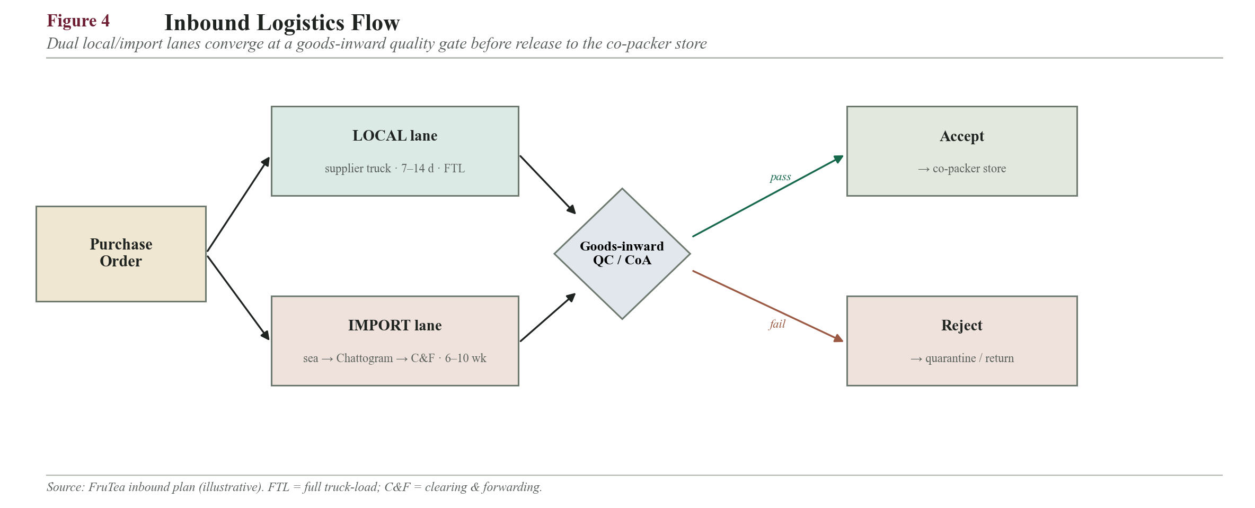
Inbound logistics flowchart: order -> local vs import lane -> port/C&F -> goods-inward QC -> co-packer store
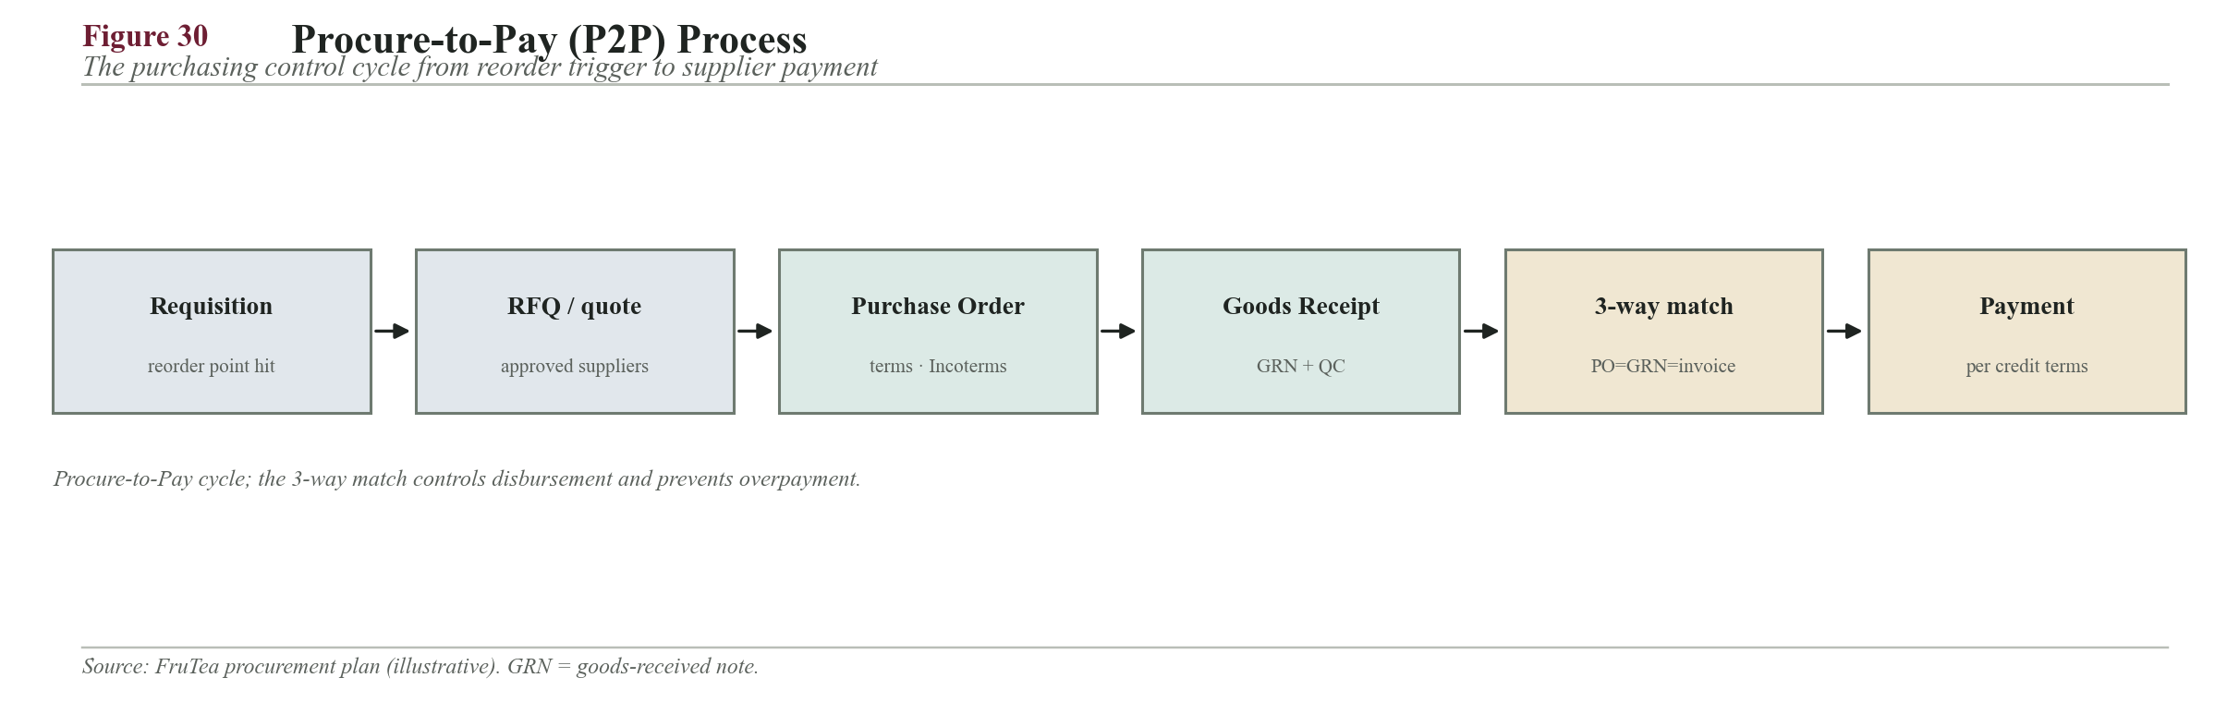
Figure 30. Procure-to-Pay cycle — the 3-way match (PO = GRN = invoice) controls disbursement.

12.6 Inventory Management — EOQ, Safety Stock, ROP, ABC (worked)

12.6.1 Economic Order Quantity (EOQ)
The EOQ model, EOQ = sqrt(2DS/H), sets the order size that minimises combined ordering and holding cost (Chopra & Meindl, 2019). It is applied to a local high-volume input (sugar) and an imported high-value input (fruit powder) to demonstrate why the two are ordered on completely different cycles.
Sugar (local): D = 37,200 kg/yr; ordering cost S = Tk 1,500/order; value Tk 120/kg; H = 25% x 120 = Tk 30/kg/yr.
EOQ = sqrt(2 x 37,200 x 1,500 / 30) = sqrt(3,720,000) = 1,929 kg per order
Orders/yr = 37,200 / 1,929 = 19.3 -> cycle = 365 / 19.3 = ~19 days (~2.7 weeks)
Fruit powder (imported): D = 2,100 kg/yr; S = Tk 25,000/order (LC, freight, C&F); value Tk 900/kg; H = 25% x 900 = Tk 225/kg/yr.
EOQ = sqrt(2 x 2,100 x 25,000 / 225) = sqrt(466,667) = 683 kg per order
Orders/yr = 2,100 / 683 = 3.07 -> cycle = 365 / 3.07 = ~119 days (~4 months)
Interpretation. The high import ordering cost pushes fruit powder to large, roughly quarterly orders, which in turn justifies a larger safety stock; inexpensive-to-order local sugar is replenished every 2-3 weeks, tying up minimal cash. This differentiated policy is exactly what an instant-powder maker with mixed local/import sourcing requires.

12.6.2 Safety Stock and Reorder Point (95% service, with lead-time variability)
Safety stock is sized with the combined-variability formula SS = Z x sqrt(L x sd^2 + d^2 x sL^2), with the reorder point ROP = d x L + SS (Chopra & Meindl, 2019). Z = 1.65 for a 95% cycle-service level. Including lead-time variability (sL) is essential for imports, whose customs-clearance times are volatile.
Fruit powder: d = 2,100/365 = 5.75 kg/day; demand CV 20% -> sd = 1.15; L = 56 days; lead-time SD sL = 14 days.
SS = 1.65 x sqrt(56 x 1.15^2 + 5.75^2 x 14^2) = 1.65 x sqrt(74.1 + 6,479.8) = 1.65 x 80.96 = 134 kg (~23 days cover)
ROP = 5.75 x 56 + 134 = 322 + 134 = 456 kg
Sugar: d = 101.9 kg/day; CV 15% -> sd = 15.3; L = 10 days; sL = 3 days.
SS = 1.65 x sqrt(10 x 15.3^2 + 101.9^2 x 3^2) = 1.65 x sqrt(2,341 + 93,452) = 1.65 x 309.5 = 511 kg (~5 days)
ROP = 101.9 x 10 + 511 = 1,019 + 511 = 1,530 kg
Interpretation. Imported fruit powder needs about 23 days of buffer against only about 5 days for local sugar. The mathematics quantifies why import-side inventory dominates working capital and reinforces the strategic choice to keep the bulk of the blend (sugar) local.

12.6.3 ABC Analysis (by annual spend)
Item | Annual spend (Tk) | % of spend | Cumulative % | Class
Tea extract | 6,480,000 | 40.2% | 40.2% | A
Sugar | 4,464,000 | 27.7% | 67.9% | A
Flavour | 2,250,000 | 13.9% | 81.8% | A
Fruit powder | 1,890,000 | 11.7% | 93.5% | B
Maltodextrin | 720,000 | 4.5% | 98.0% | B
Citric/malic acid | 324,000 | 2.0% | 100% | C

Result. The three A-items (tea, sugar, flavour) represent about 82% of spend and receive tight control — frequent review, EOQ ordering and dual sourcing. B-items get periodic review; the single C-item (acid) is bulk-ordered with loose control. Management effort is concentrated where the money is (Jacobs & Chase, 2021).
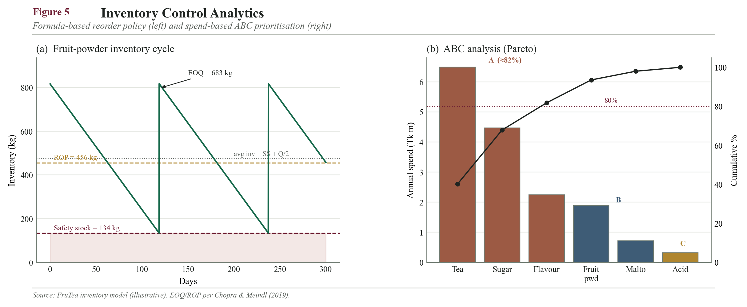
Inventory saw-tooth chart (ROP, safety stock, lead time) for fruit powder + ABC Pareto chart

12.6.5 Calculation summary (data behind the charts)
EOQ / ROP / safety-stock parameters and results for the two representative items:
Parameter (symbol) | Sugar (local) | Fruit powder (imported)
Annual demand D (kg) | 37,200 | 2,100
Ordering cost S (Tk/order) | 1,500 | 25,000
Unit value (Tk/kg) | 120 | 900
Holding cost H = 25% (Tk/kg/yr) | 30 | 225
EOQ = sqrt(2DS/H) (kg) | 1,929 | 683
Orders / year (D/Q*) | 19.3 | 3.07
Order cycle (days) | ~19 | ~119
Daily demand d (kg/day) | 101.9 | 5.75
Lead time L (days) | 10 | 56
Safety stock SS (kg) | 511 | 134
Reorder point ROP = dL + SS (kg) | 1,530 | 456

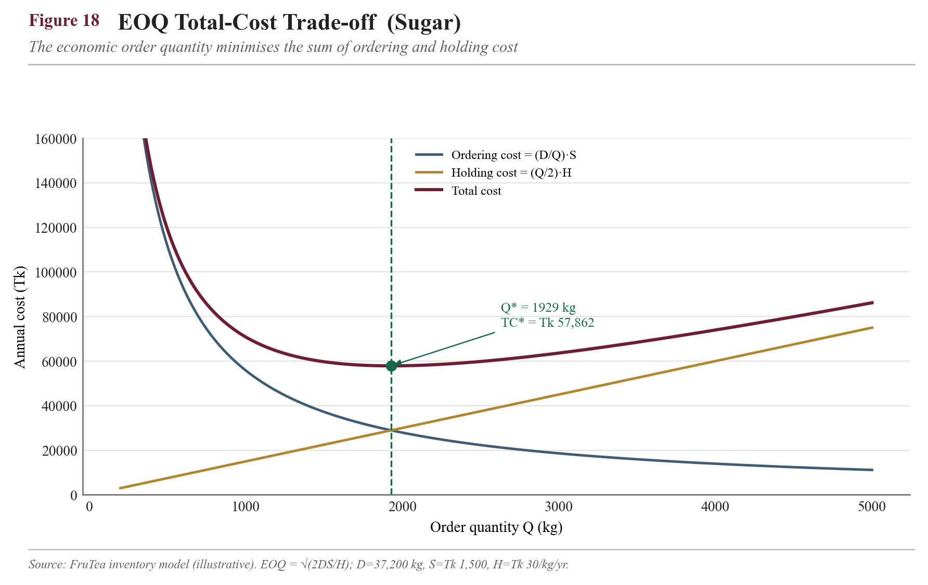
Figure 18. EOQ total-cost trade-off for sugar — total cost is minimised at Q* = 1,929 kg.
Safety stock rises convexly with the target service level (Z-value); the data points behind the curve:
Service level | Z-value | Safety stock (kg) — fruit powder
90% | 1.28 | 104
95% (chosen) | 1.65 | 134
97.5% | 1.96 | 159
99% | 2.33 | 189
99.9% | 3.09 | 250

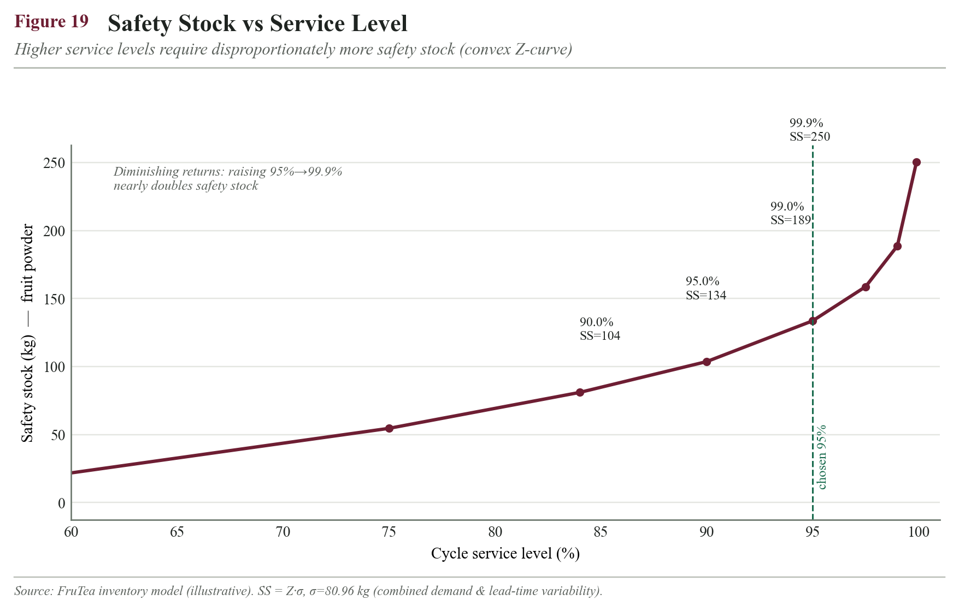
Figure 19. Safety stock vs service level — raising 95% to 99.9% nearly doubles the buffer (σ = 80.96 kg).
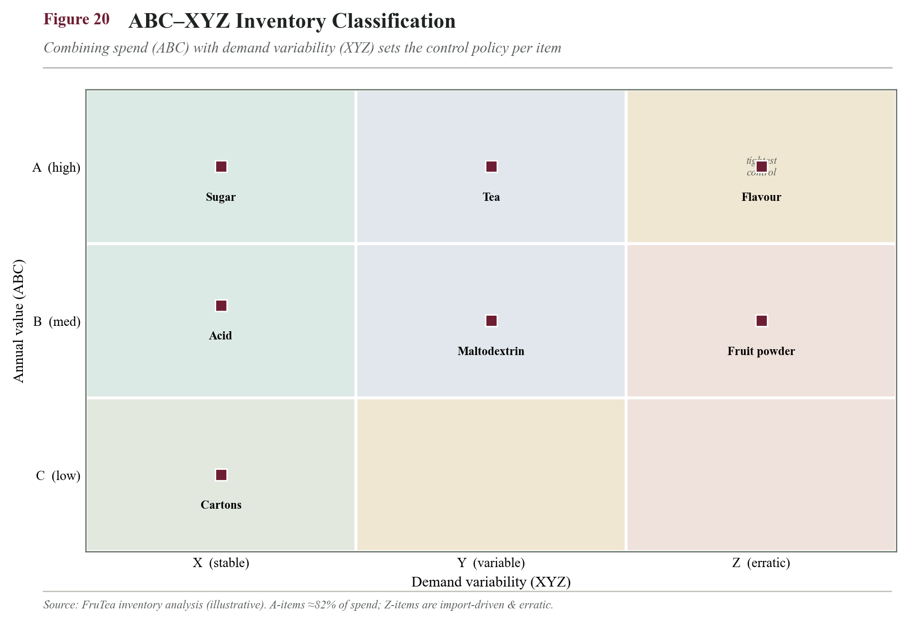
Figure 20. ABC–XYZ classification — combining annual value with demand variability sets the control policy per item.

12.6.4 Closing the inventory-turnover gap (worked)
The Year-1 turnover of ~7.5x (12.13) sits below the 8-12x target, driven almost entirely by the long import lead time inflating fruit-powder safety and cycle stock. The corrective lever is operational, not financial: qualify a third, faster fruit-powder source (or hold a small regional consignment buffer) to cut effective lead time from 56 to ~35 days.
New fruit-powder SS = 1.65 x sqrt(35 x 1.15^2 + 5.75^2 x 9^2) = 1.65 x sqrt(46.3 + 2,679) = 1.65 x 52.2 = 86 kg (was 134 kg)
Raw-material avg inventory falls ~Tk 2.3m -> ~Tk 1.6m -> total avg inventory ~Tk 2.8m
Turnover = 26,400,000 / 2,800,000 = 9.4x/yr -> DIO = 365 / 9.4 = ~39 days (now inside 8-12x target)
Reading. A purely supply-side action (a third source shortening lead time) moves turnover from below-target to mid-target and cuts ~10 days of inventory, without touching price or margin. This is the kind of concrete, quantified fix an investor wants to see attached to a flagged weakness.

12.6.6 Additional supply-chain equations applied
Beyond the core inventory formulae, the following supply-chain relationships are applied to FruTea, each with its worked value:
Relationship | Equation | Worked FruTea value
Little's Law (flow inventory) | I = R x T | R = 5,000 kg/mo, T = 2.5 wk = 0.58 mo -> I = 2,900 kg finished goods
EOQ total cost | TC* = sqrt(2DSH) | Sugar: sqrt(2 x 37,200 x 1,500 x 30) = Tk 57,862/yr
Economic Production Qty (own line) | Q*p = EOQ x sqrt(1/(1 - d/p)) | d/p ~ 0.33 -> Q*p ~ 1.22 x EOQ (Year-2 in-house run)
Capacity utilisation | U = throughput / capacity | 5,000/20,000 = 25% avg; 6,750/20,000 = 34% peak
Inventory turnover | Turns = COGS / avg inventory | 26.4m / 3.5m = 7.5x (9.4x after lead-time fix)
Cash-to-cash cycle | CCC = DIO + DSO - DPO | 49 + 20 - 30 = ~39 days (operational input to Finance)
Bullwhip ratio | BW = Var(orders) / Var(demand) | Target ~1.0 via level scheduling + short local cycle

12.7 Production Planning and Capacity
Method — Make-to-Stock via a rolling Master Production Schedule (MPS). Production quantity per SKU = forecast demand + target finished-goods buffer - current stock (Jacobs & Chase, 2021). In Year 1 the co-packer runs weekly batches grouped by flavour to minimise changeover and cleaning downtime, with Lemon and Mango prioritised as the A-SKUs. From Year 2 the hybrid model brings blending and sachet-filling in-house on a continuous schedule once volume (9-15 t/month) justifies dedicated lines, retaining the co-packer as surge capacity.
Capacity must be sized to the seasonal peak, not the average. Because demand peaks at a seasonal index of about 1.35 in summer (12.10), planned capacity is set at 1.35 x 5,000 = 6,750 kg/month, not the 5,000 kg average. Booking co-packing capacity to the peak — and building finished-goods stock ahead of the summer and festive windows — prevents stock-outs precisely when demand and margin are highest.

12.7.1 Make-or-buy switch trigger (volume-based)
The hybrid model's move from co-packer (buy) to an in-house line (make) is governed by a volume trigger, not a hunch. A dedicated entry-level blending + sachet-filling line runs efficiently at roughly 15,000 kg/month; owning it only makes operational sense once demand consistently uses a majority of that capacity, so that the line is not idle.
Switch trigger: sustained demand >= ~60-70% of own-line capacity = ~9,000-10,000 kg/month
On the growth path (Year 1 = 5 t, Year 2 = 9 t, Year 3 = 15 t/month), demand crosses this threshold in Year 2, which is exactly when the plan brings production in-house while retaining the co-packer for surge and backup. The financial break-even (capex payback of own line vs cumulative tolling fees) is quantified in the Finance section; this plan fixes only the operational trigger point.
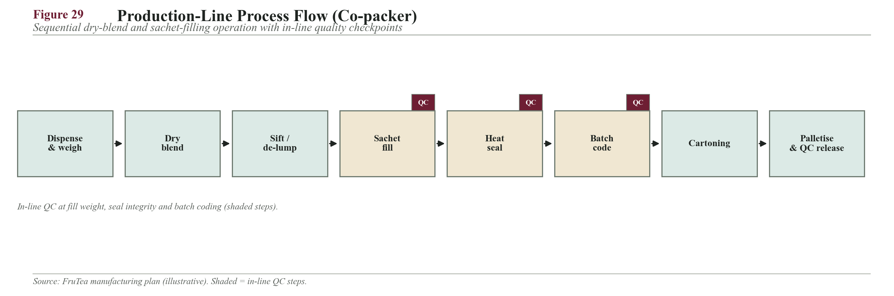
Figure 29. Co-packer production-line process flow with in-line quality checkpoints.
Capacity vs demand across the three-year growth path:
Year | Monthly demand | Co-pack capacity | Own-line capacity | Utilisation of co-pack
Year 1 | 5 t | 20 t | — | 25% (peak 34%)
Year 2 | 9 t | 20 t | 15 t | crosses in-house trigger (9–10 t)
Year 3 | 15 t | 20 t (surge) | 15 t | own line ~100%; co-pack for surge

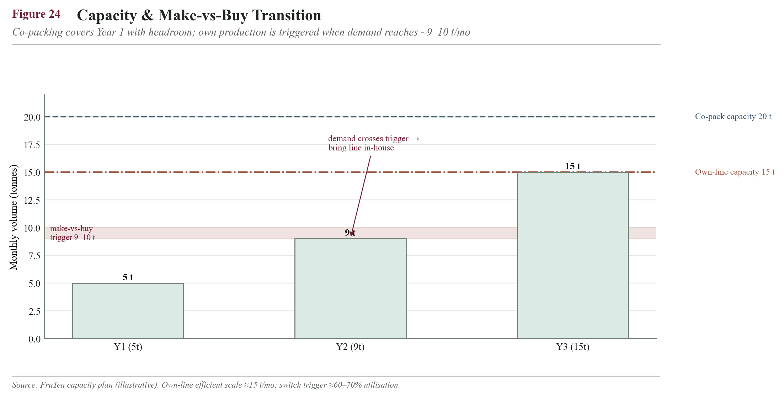
Figure 24. Capacity and make-vs-buy transition — demand reaches the ~9–10 t/mo in-house trigger in Year 2.

12.8 Warehousing and Facility Mapping
FruTea operates from a single rented central-Dhaka unit of approximately 2,000 sq ft during launch (location justified mathematically in 14.1). The layout is zoned to enforce one-directional flow from receiving to dispatch, preventing cross-contamination between inbound raw goods and outbound finished product, in line with good-manufacturing-practice storage principles (Codex Alimentarius Commission, 2020).

12.8.1 Zone mapping and space allocation
Zone | Approx. area | Purpose / notes
Receiving & goods-inward QC | 250 sq ft | Unload, verify, quarantine-hold pending QC release
Raw & packaging staging | 300 sq ft | Short-hold buffer for inputs feeding the co-packer cycle
Finished-goods racked storage | 900 sq ft | Pallet racking, FEFO, ABC velocity slotting
Pick / pack / dispatch | 350 sq ft | Order assembly and courier/distributor loading bay
Returns & quarantine | 100 sq ft | Segregated hold for returns, damages, recalls
Office & records | 100 sq ft | Order desk, documentation, KPI dashboards
Total | ~2,000 sq ft | —

Slotting logic. Fast-moving A-SKUs (Lemon, Mango) are slotted in the 'golden zone' nearest the dispatch bay to minimise picker travel and order-cycle time; slow-moving flavours and bulk packs are stored deeper. This velocity-based slotting directly supports the <=24-hour Dhaka fulfilment KPI.
Space verification. Finished-goods buffer = 2.5 weeks of 5 t/month = (2.5/4.33) x 5,000 = ~2,890 kg. At ~250 kg per pallet and ~1.5 sq ft footprint per stacked pallet-equivalent including a ~40% aisle allowance, ~900 sq ft of racked storage comfortably holds the buffer, confirming the 2,000 sq ft total.

12.8.2 Storage environment specification
Parameter | Specification | Reason
Temperature | <= 25 C (ambient, cool) | Preserves flavour volatiles; no cold chain needed
Relative humidity | < 60% RH (dehumidified) | Powder is hygroscopic; prevents caking/clumping
Stacking | On pallet racking, off the floor | Prevents moisture ingress and pest access
Pest control | Sealed, baited, monitored monthly | Food-safety and BFSA compliance
Segregation | Raw / finished / quarantine separated | Prevents cross-contamination and mix-ups

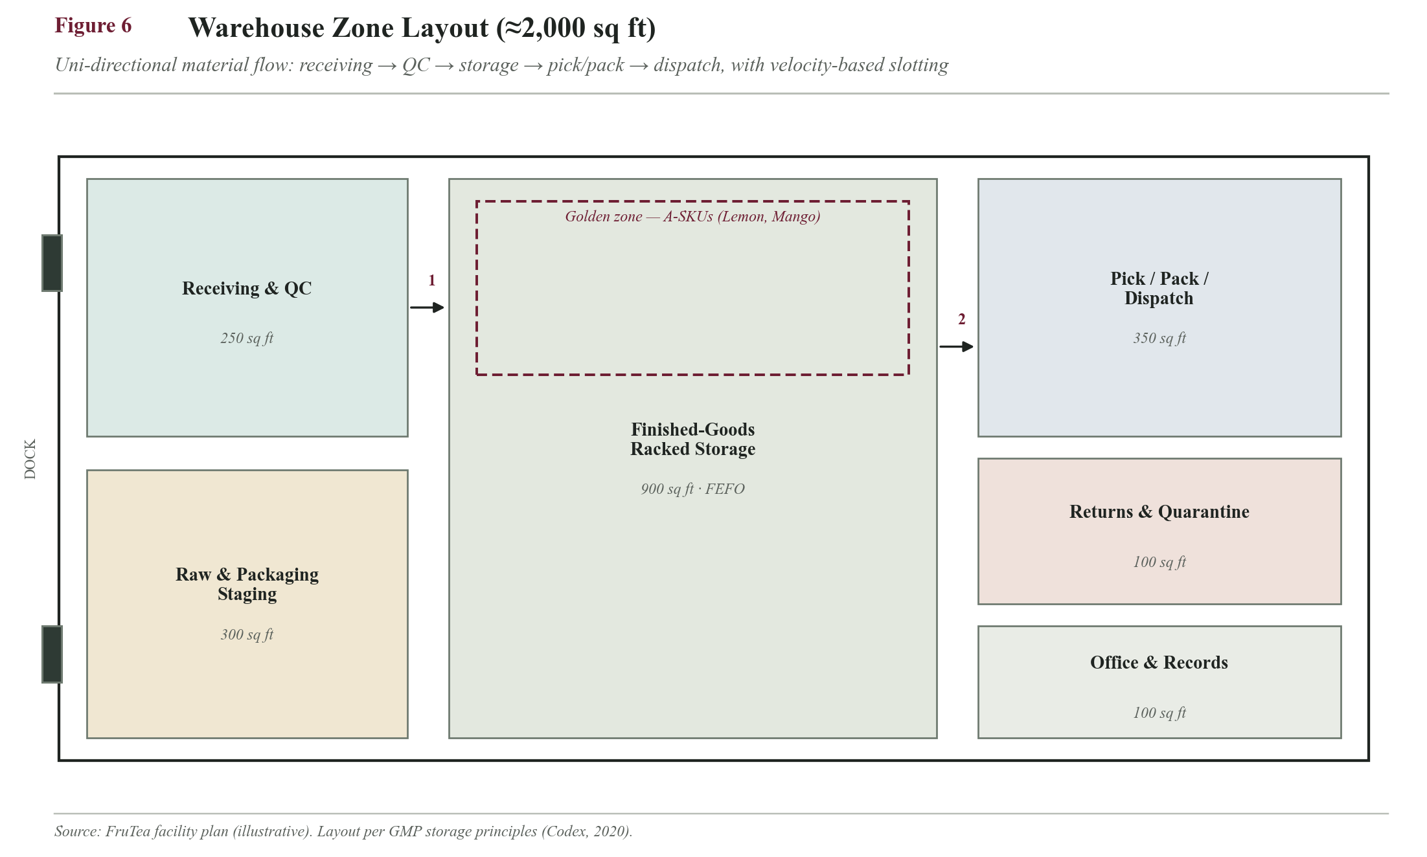
Warehouse zone-map floor plan with the six zones, flow arrows and golden-zone A-SKU slotting

12.9 Outbound Distribution
- Primary (distributor-led): appointed distributors break bulk to traditional retail, tea stalls and small shops.
- Direct-to-channel: super shops (Shwapno, Meena Bazar, Agora), universities and canteens, cafes and restaurants, and corporate/office accounts.
- E-/F-commerce: the FruTea website and social shop are fulfilled by third-party couriers (Pathao, RedX, Sundarban).
Mode and method: hub-and-spoke with outsourced 3PL — small covered vans intra-Dhaka and contracted covered trucks inter-city. Owning no fleet keeps distribution a variable per-trip cost, feeding the transport mathematics in 14.1.
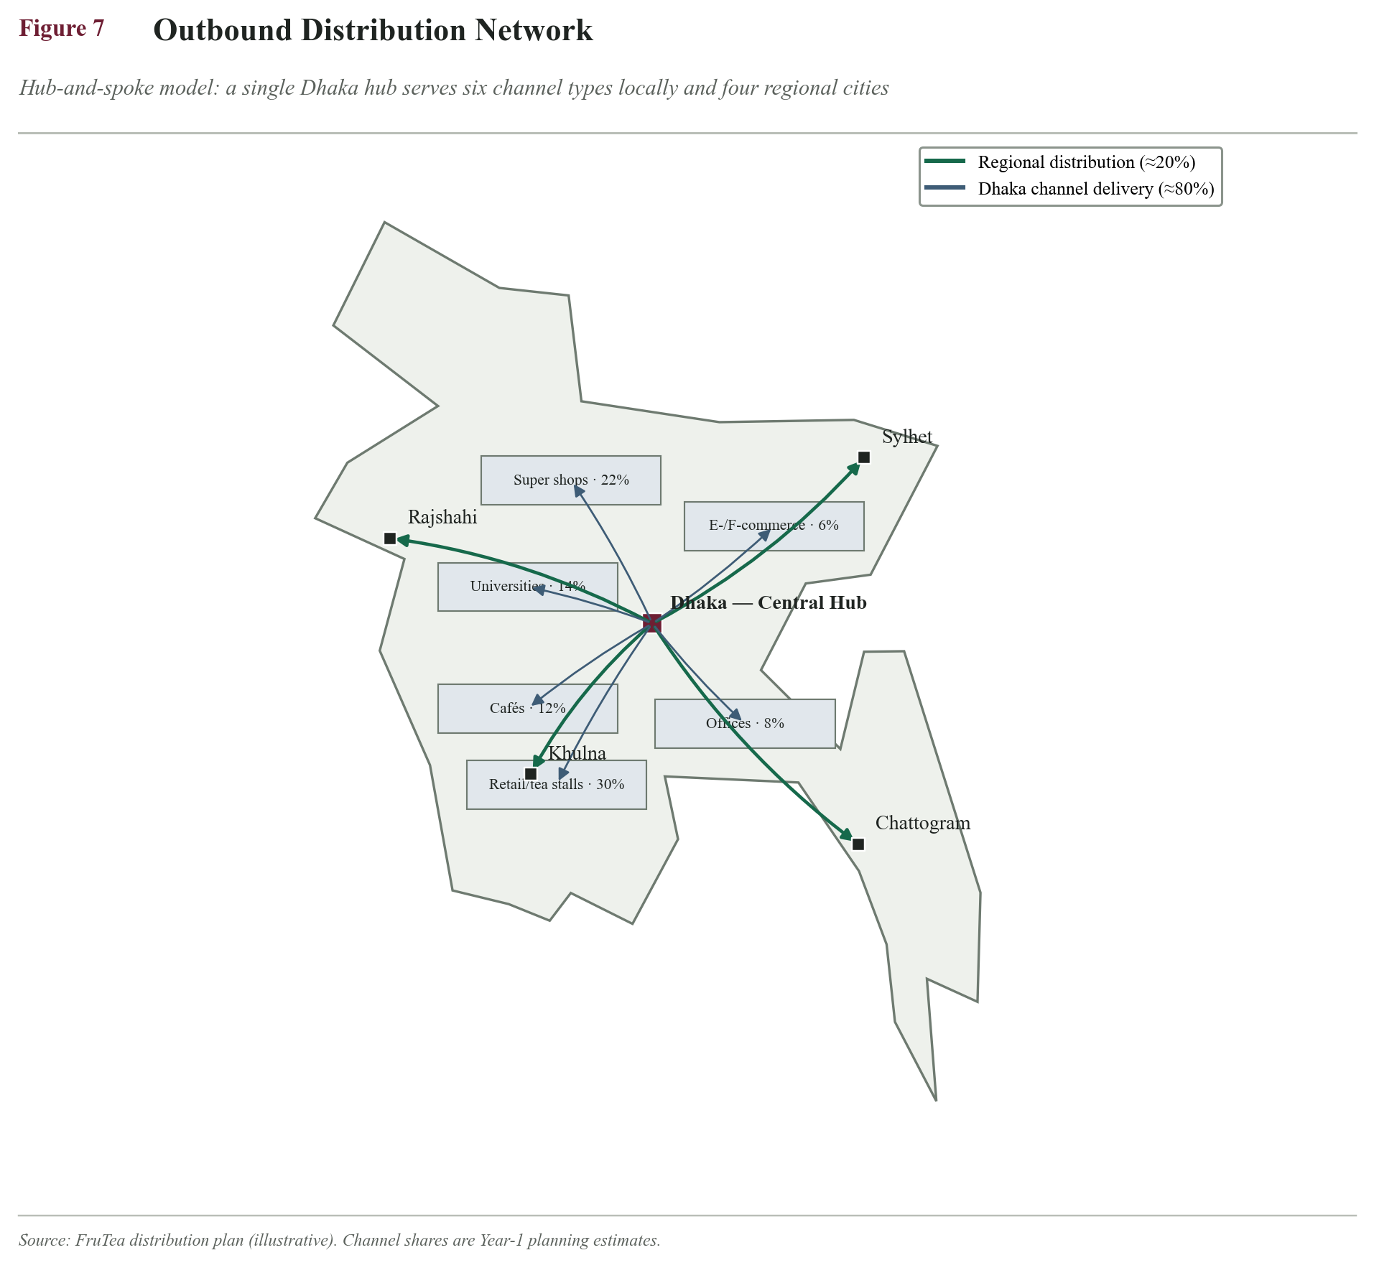
Outbound distribution network map: Dhaka hub -> channel spokes across Dhaka and regional cities

12.10 Demand Forecasting and Seasonality
With no sales history at launch, forecasting begins qualitatively (planned channel coverage x expected reorder rate, informed by primary market research) and transitions to quantitative time-series methods as data accumulates (Heizer et al., 2020). For a cold-beverage product in Bangladesh, however, the single most important planning variable is seasonality, which is analysed explicitly below.

12.10.1 When demand hikes, and why (product-specific)
FruTea demand is strongly seasonal and event-driven, for reasons rooted in Bangladeshi climate and culture:
- Summer heat (April-June): Bangladesh summers are hot and humid, driving a sharp rise in cold and refreshing beverage consumption — the core use-case for iced FruTea. This is the primary annual peak.
- Ramadan and Eid (iftar demand): during Ramadan, households and restaurants consume large volumes of fruit-based and refreshing drinks at iftar, spiking demand for fruity, easy-to-prepare beverages. Because Ramadan shifts ~10-11 days earlier each year on the Gregorian calendar, when it coincides with summer the peak is amplified further (a multiplicative effect on top of the summer index).
- Pohela Boishakh and other festivals (mid-April): festival gatherings and hospitality lift demand for shareable drinks, coinciding with the onset of summer.
- University and exam seasons: students buy FruTea as a convenient, affordable pick-me-up during late-night study and exam periods, supporting steadier campus-channel demand.
- Winter dip (November-January): cool weather reduces cold-drink demand; this trough is used for maintenance, promotions and building working capital, with the hot-serve suggestion mitigating the fall.
These drivers are quantified as a monthly seasonal index (annual mean = 1.00), used to build stock ahead of peaks:
Month | Jan | Feb | Mar | Apr | May | Jun | Jul | Aug | Sep | Oct | Nov | Dec
Seasonal index | 0.75 | 0.85 | 1.05 | 1.25 | 1.35 | 1.20 | 1.05 | 0.95 | 1.05 | 0.90 | 0.80 | 0.75

Planning implication: peak-month demand = 1.35 x 5,000 = 6,750 kg versus a 0.75 x 5,000 = 3,750 kg winter trough — a 1.8x swing. Production and safety stock are built up in February-March ahead of the April-June peak, and co-packing capacity is booked to the peak (12.7).

12.10.2 Forecasting model (worked) and accuracy
A six-month illustration (monthly demand, '000 cups) demonstrates the method and its error measurement:
Month | M1 | M2 | M3 | M4 | M5 | M6
Actual demand | 250 | 260 | 290 | 320 | 360 | 400

3-month moving average, forecast M7: (320 + 360 + 400) / 3 = 360 ('000 cups).
Exponential smoothing (alpha = 0.3), F(t+1) = alpha*A(t) + (1-alpha)*F(t), seeded F2 = 250:
F3=0.3(260)+0.7(250)=253 ; F4=0.3(290)+0.7(253)=264 ; F5=0.3(320)+0.7(264)=281
F6=0.3(360)+0.7(281)=305 ; F7=0.3(400)+0.7(305)=333 ('000 cups)
Forecast accuracy (MAPE of the smoothing model, M3-M6): MAPE = mean(|A-F|/A).
APE: M3=12.8% ; M4=17.5% ; M5=22.0% ; M6=23.9% -> MAPE = 19.0%
Interpretation. MAPE of 19% meets the <=20% target, but both models lag under a rising trend (ES forecasts 333 vs MA 360 for M7). FruTea therefore adopts a moving average multiplied by the monthly seasonal index above, and migrates toward a trend-adjusted (Holt) model as history grows (Heizer et al., 2020).
Forecast data behind the tracking chart (exponential smoothing, α = 0.3) and the error calculation:
Month | Actual (A) | Forecast (F) | Abs % error
M3 | 290 | 253 | 12.8%
M4 | 320 | 264 | 17.5%
M5 | 360 | 281 | 22.0%
M6 | 400 | 305 | 23.9%
Forecast M7 | — | 333 (ES) / 360 (MA) | MAPE = 19.0%

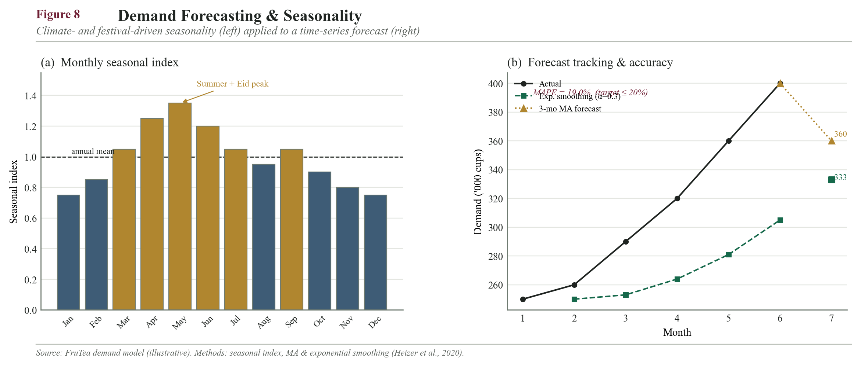
Monthly demand curve overlaid with the seasonal index; actual-vs-forecast (MA vs ES) tracking chart

12.11 Quality Control and Specifications
Quality is controlled at every node of the chain, not only at manufacturing, under a HACCP-based framework with full batch-code traceability enabling targeted recall (Codex Alimentarius Commission, 2020). Standards followed: BSTI, BFSA and HACCP.

12.11.1 Checkpoints across the chain
Stage | Checkpoint
Supplier | CoA, food-grade certification, pre-shipment sample approval
Goods inward | Identity, weight, moisture, foreign matter, documents
In-process (co-packer) | Blend uniformity, dosing, seal integrity, fill weight, batch coding
Finished goods | Solubility, taste/aroma panel, moisture, leak test, expiry coding
Warehouse | Humidity monitoring, FEFO compliance, damage checks
Outbound | Dispatch inspection: correct SKU/qty, undamaged cartons

12.11.2 Finished-product QC specifications
Every batch is released only against defined acceptance limits, benchmarked to Codex and BSTI norms for instant food powders:
Quality parameter | Specification / acceptance limit
Moisture content | <= 5% (w/w) — protects against caking and microbial growth
Solubility | Complete dissolution <= 30 s in 200 ml water at 25 C
pH (1% solution) | 3.0 - 4.5 (acidic fruit-tea profile)
Fill weight tolerance | +/- 3% (15 g sachet = 14.55 - 15.45 g)
Seal integrity | No leakage under dye/vacuum test
Total plate count | <= 10,000 cfu/g
Yeast & mould | <= 100 cfu/g
Coliforms / E. coli / Salmonella | Absent
Foreign matter | Nil

Traceability and recall. Each sachet carries a batch code linking it to production date, line, and raw-material lots, enabling a targeted recall of a single batch rather than the whole market. A documented recall SOP and periodic mock-recall drills (14.7) verify that any affected lot can be traced and withdrawn within a defined time window.

12.11.3 Shelf-life and stability validation protocol
The 12-month shelf-life claim is not assumed; it is validated by a formal stability study before launch, essential for a hygroscopic powder in Bangladesh's hot, humid climate. Two parallel studies are run and the results substantiate the printed expiry date and the storage specification in 12.8.2.
Study | Conditions | Duration & test points | Purpose
Accelerated stability | 40 C / 75% RH | 0, 1, 3, 6 months | Early prediction of 12-month ambient life
Real-time stability | 30 C / 65% RH (BD ambient) | 0, 3, 6, 9, 12 months | Confirms the actual on-shelf shelf life

Parameters tracked at each point: moisture uptake, water activity (target aw < 0.6 to inhibit microbial growth), solubility, colour, flavour (sensory panel) and microbial counts. Passing all points across 12 months at ambient validates the claim; the accelerated study gives an early read so launch is not delayed a full year.
Packaging linkage. Shelf life is only as good as the barrier: the laminated sachet film (12.3) is specified for low moisture-vapour transmission precisely so the validated aw and moisture limits hold through the 12 months in humid storage.

12.11.4 Wastage, spoilage and write-off basis
The <=1% damage/rejection KPI is grounded in the product's nature, not optimism. A dry, ambient-stable powder with a 12-month life carries far lower spoilage risk than perishable or chilled goods; the residual loss is mainly transit damage and slow-moving expiry, both controlled by design:
- Expiry write-off minimised by FEFO issue + short 2.5-week finished-goods cover + seasonal pre-build timed to sell through before peak ends.
- Transit damage (~0.5% benchmark) minimised by rigid shipping cartons, palletised handling and QC dispatch checks.
- Moisture spoilage prevented by barrier film, anti-caking agent and <60% RH storage (validated in 12.11.3).
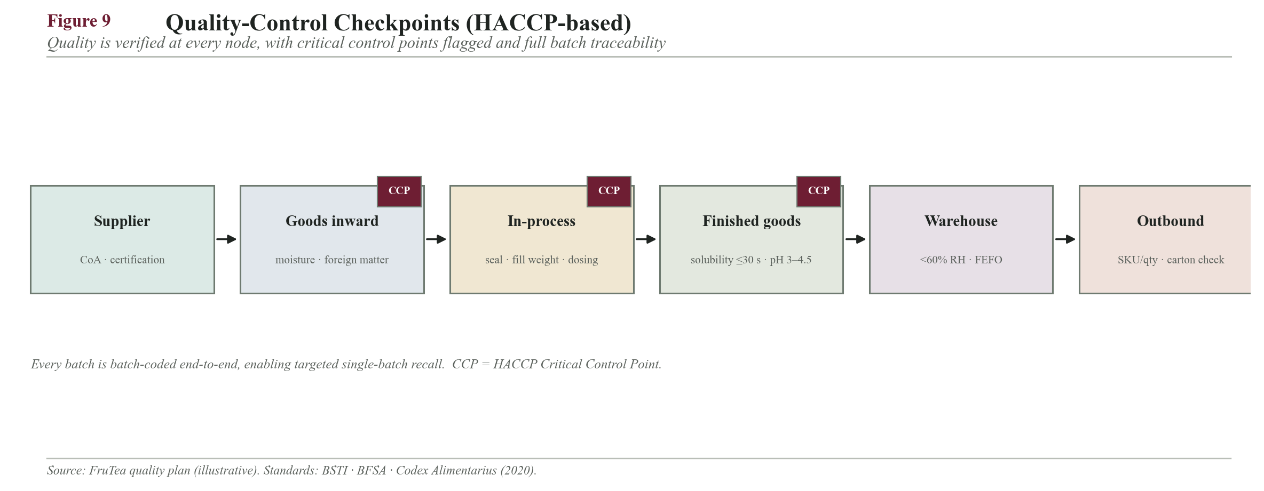
QC checkpoint flow with the HACCP critical control points marked
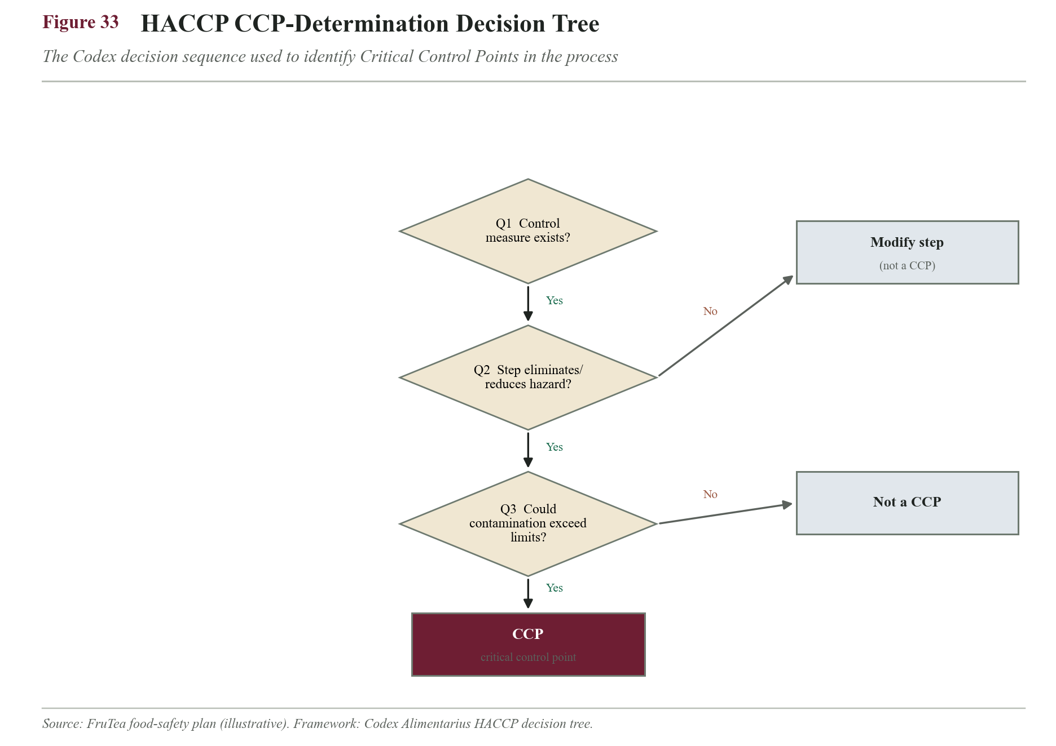
Figure 33. HACCP CCP-determination decision tree (Codex sequence).
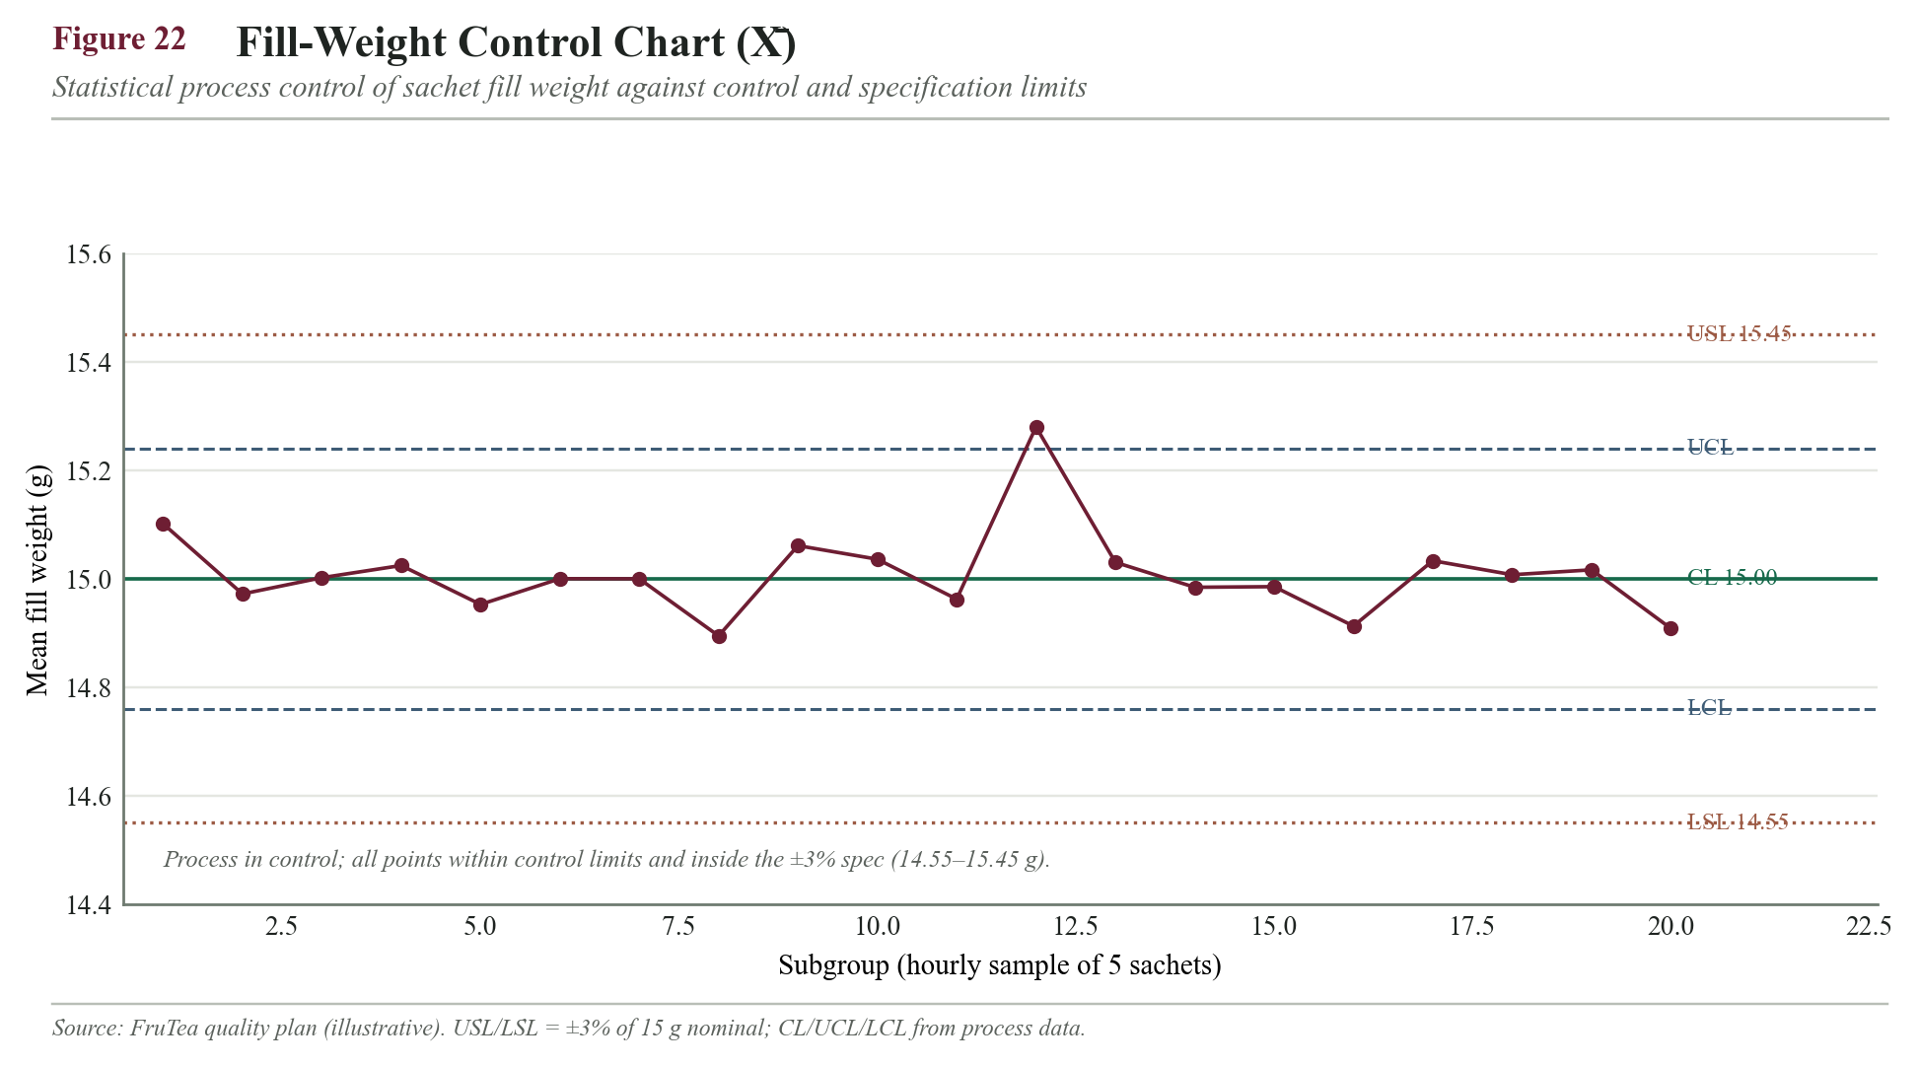
Figure 22. Fill-weight X-bar control chart — the filling process stays within control and the ±3% spec (14.55–15.45 g).
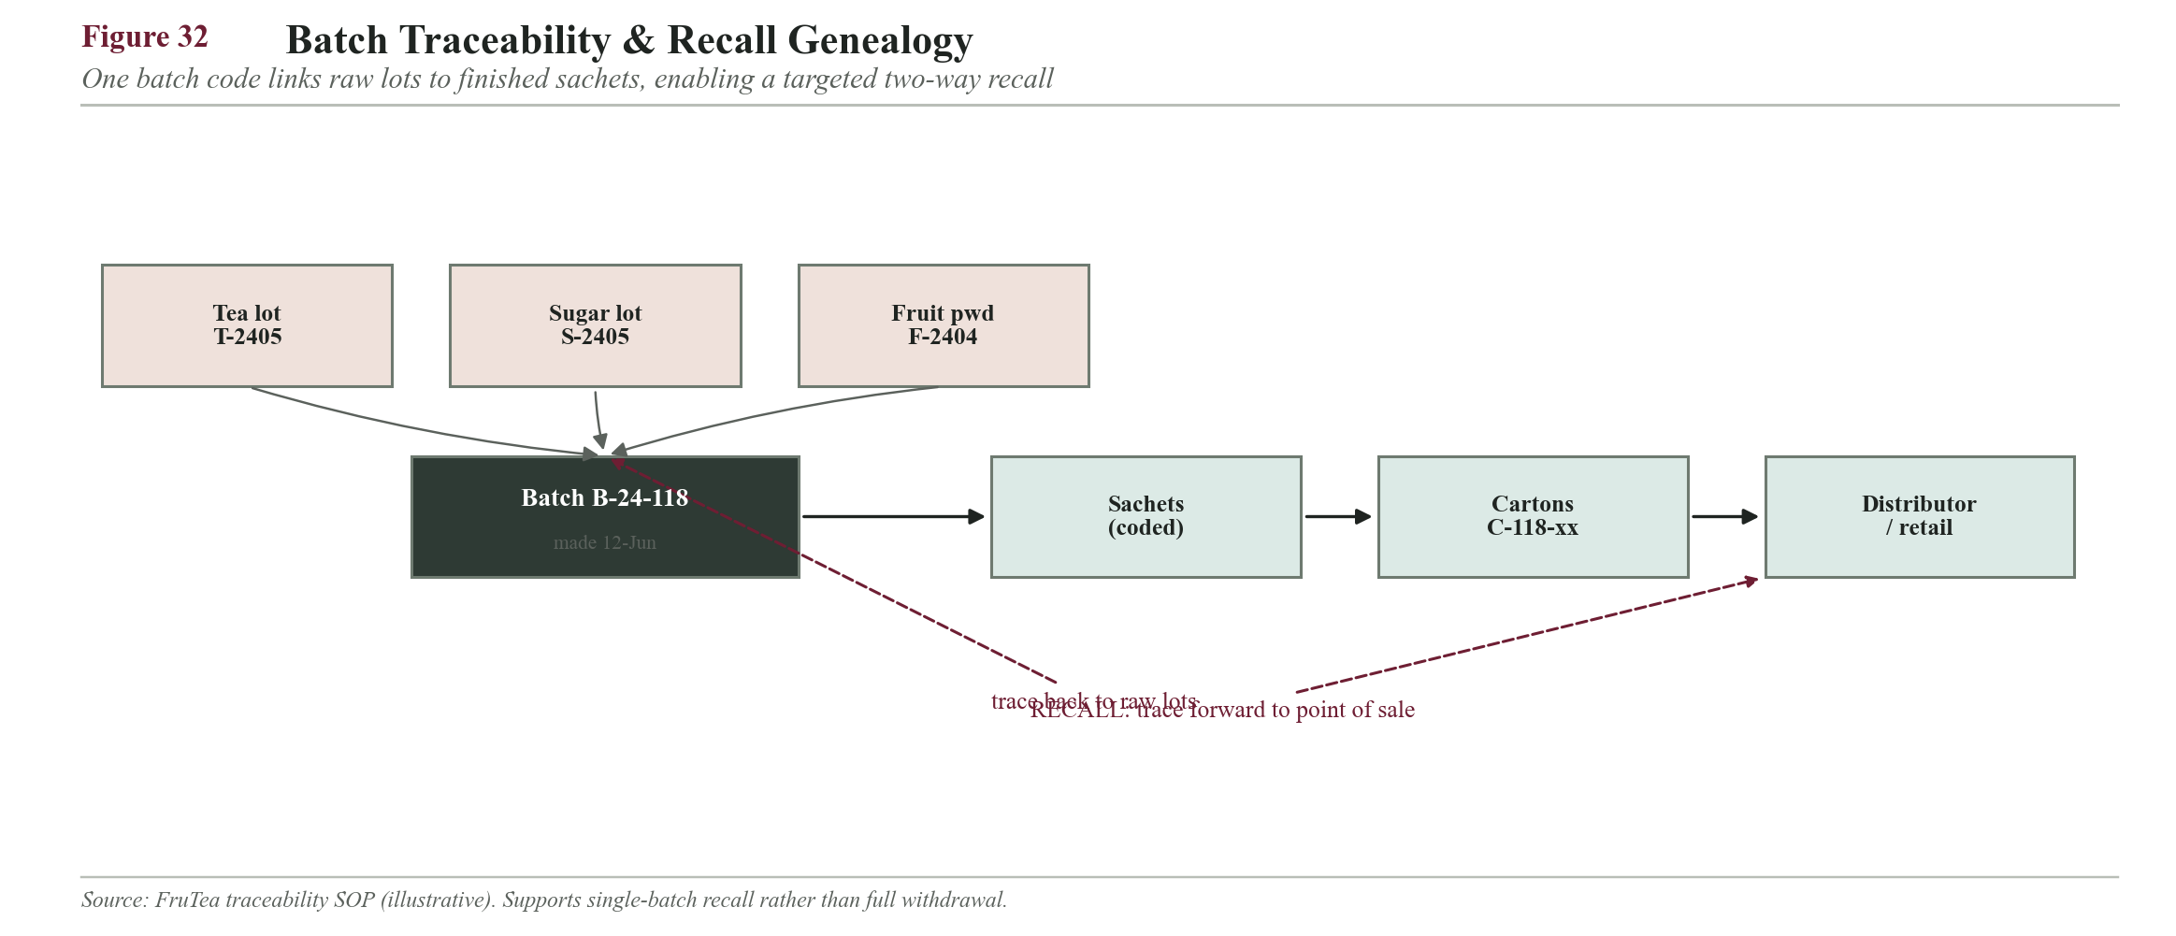
Figure 32. Batch-traceability genealogy — one code links raw lots to point of sale for targeted recall.
Stability-study data (moisture, % w/w) validating the 12-month shelf life:
Month | 0 | 1 | 3 | 6 | 9 | 12 | Limit
Accelerated 40C/75%RH | 2.5 | 2.9 | 3.4 | 3.9 | — | — | ≤5%
Real-time 30C/65%RH | 2.5 | 2.7 | 2.9 | 3.1 | 3.4 | 3.7 | ≤5%

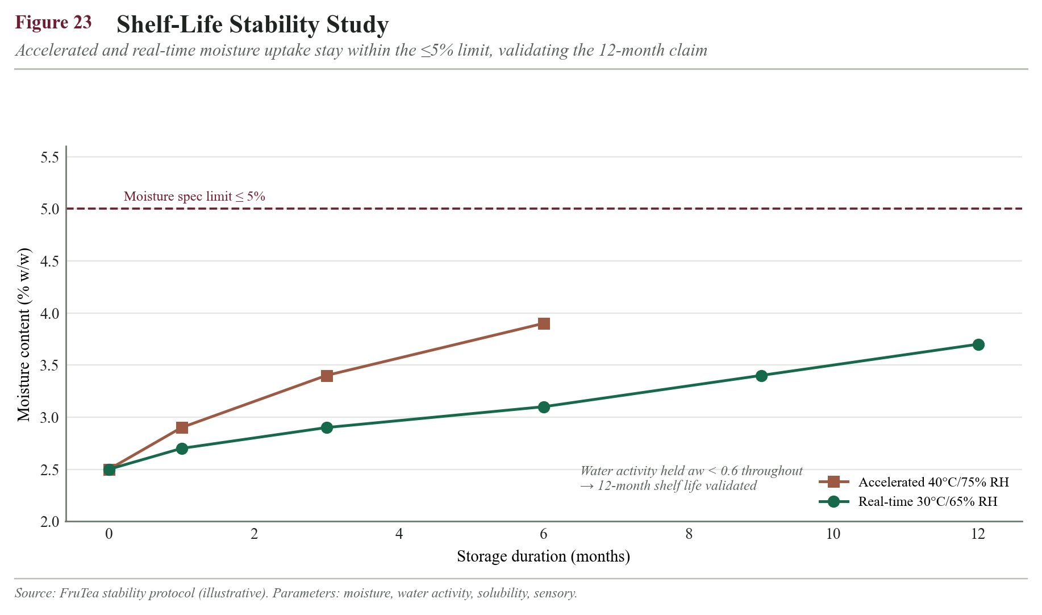
Figure 23. Shelf-life stability study — moisture stays below the 5% limit; water activity held aw < 0.6.

12.12 SCM Risks and Mitigation
Risk | Likelihood | Impact | Mitigation
Import delay / port congestion | Medium | High | Dual sourcing + ~23-day fruit-powder safety stock; order on forecast
Forex / import-cost rise | High | Medium | Localise 80%+ of blend weight; forward-plan LCs; price buffer
Sugar price volatility | Medium | Medium | Supply contracts + multiple local mills
Supplier quality failure | Low | High | CoA + inward QC + approved-supplier list + quarantine
Co-packer reliability (Year 1) | Medium | High | Backup co-packer; hybrid shift to own plant
Moisture damage / clumping | Medium | Medium | Barrier film + anti-caking agent + humidity control
Forecast error | High | Medium | Safety stock + short local cycle + seasonal-index review
Transport disruption (hartal/floods) | Medium | Medium | Multiple 3PL carriers; distributor buffers

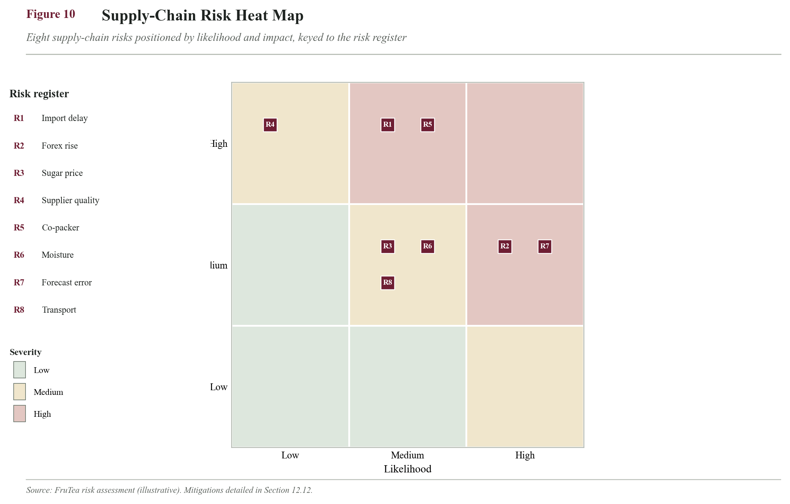
Risk probability-vs-impact heat map plotting the eight risks above

12.13 Supply Chain KPIs
KPI | Definition | Year-1 target
Order fill rate / service level | % orders complete & on time | ≥95%
Stock-out rate | % SKU-days out of stock | ≤3%
Inventory turnover | COGS / average inventory | 8-12x/yr
Total SCM cost ratio | (sourcing+inbound+storage+outbound)/sales | ≤18%
Supplier OTIF | % supplier deliveries on time in full | ≥90%
Forecast accuracy (100 - MAPE) | forecast vs actual | ≥80%
Order-to-delivery cycle | order to customer receipt | ≤3 days (Dhaka)
Damage/rejection rate | % units rejected/damaged | ≤1%

Inventory-turnover check (worked). Annual COGS ~ Tk 26.4m (ingredients Tk 16.13m + packaging & co-pack conversion ~64% uplift); average total inventory ~ Tk 3.5m (raw-material cycle + safety stock ~Tk 2.3m + ~2.5-week finished-goods buffer ~Tk 1.2m).
Turnover = 26,400,000 / 3,500,000 = 7.5x/yr -> Days Inventory Outstanding = 365 / 7.5 = ~49 days
Reading. At ~7.5x, turnover sits just below the 8-12x target, flagging the imported-input buffer as the lever to tighten (for example a third fruit-powder source to cut lead time) — an actionable, math-driven insight rather than a generic target.
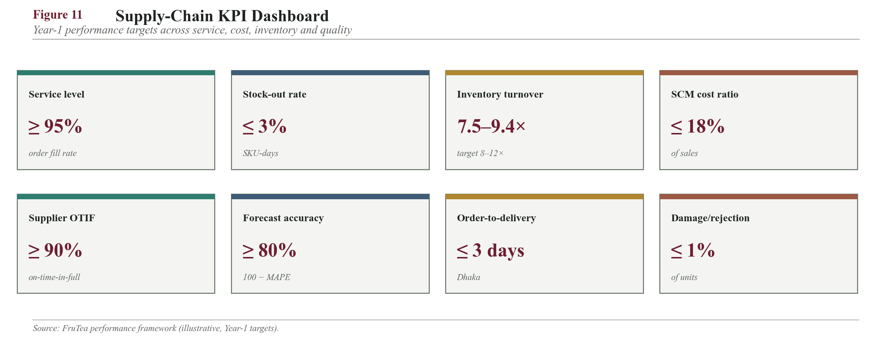
SCM KPI dashboard (gauges/tiles) for the metrics above
Composition of the total SCM cost (share of sales, within the 18% ceiling):
Cost element | Share of sales
Sourcing logistics / duty | 7%
Outbound distribution | 5%
Warehousing / storage | 3%
Inbound freight | 3%
Total SCM cost | 18%

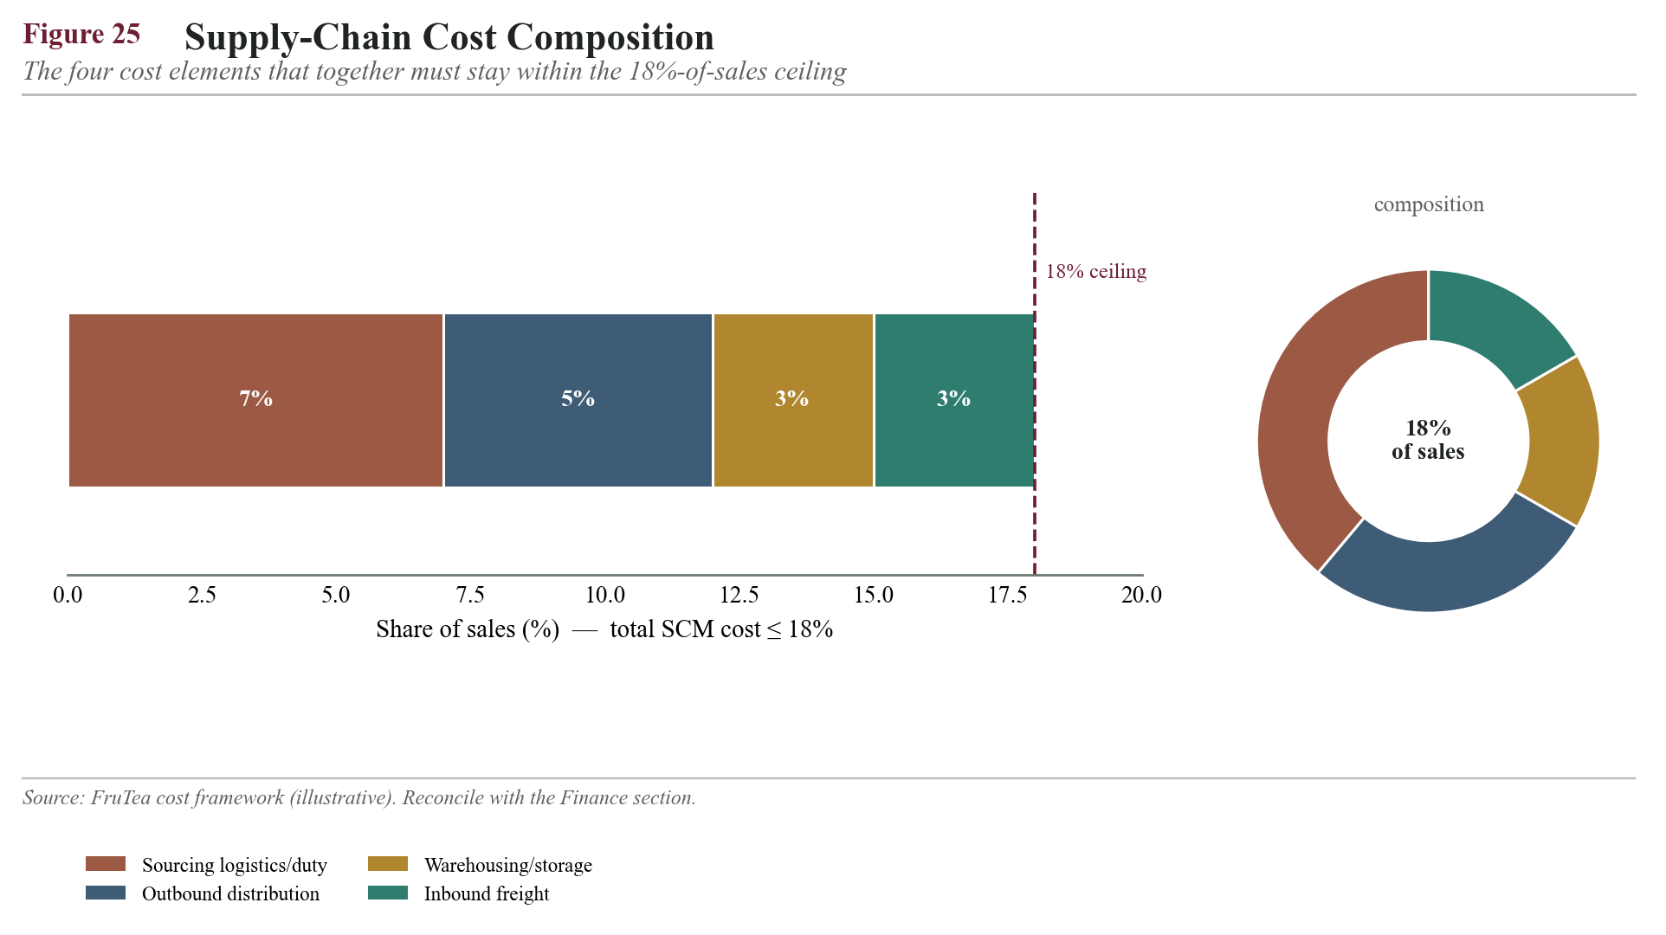
Figure 25. Supply-chain cost composition — the four elements that must stay within the 18%-of-sales ceiling.

14. Operations Plan

14.1 Business Location — Rented Warehouse (Centre-of-Gravity + Cost-to-Serve)
FruTea rents rather than buys, to stay capital-light. The site is chosen with two complementary methods: the centre-of-gravity model for the transport-optimal point (Ballou, 2004), and a total cost-to-serve comparison of three candidates.

14.1.1 Centre-of-Gravity model
Method: Cx = Sum(wi*xi)/Sum(wi), Cy = Sum(wi*yi)/Sum(wi), where wi is each market's demand weight on a map grid (km). Demand weights reflect the ~80% Dhaka concentration: Dhaka 80, Chattogram 8, Sylhet 5, Khulna 4, Rajshahi 3.
Market | x | y | weight w | w*x | w*y
Dhaka | 100 | 100 | 80 | 8,000 | 8,000
Chattogram | 200 | 40 | 8 | 1,600 | 320
Sylhet | 180 | 160 | 5 | 900 | 800
Khulna | 40 | 60 | 4 | 160 | 240
Rajshahi | 30 | 140 | 3 | 90 | 420
Sum | — | — | 100 | 10,750 | 9,780

Cx = 10,750 / 100 = 107.5 ; Cy = 9,780 / 100 = 97.8 -> centroid (107.5, 97.8)
Distance to Dhaka(100,100)=7.8 | Savar/Gazipur(75,120)=39.4 | Sylhet(180,160)=95.5
Result. The demand centroid sits essentially on Dhaka (7.8 units away, versus 39.4 for the outskirts and 95.5 for Sylhet), so the transport-optimal warehouse is central Dhaka.

14.1.2 Cost-to-serve comparison (monthly)
Assumptions: 2,000 sq ft; rent Tk/sq ft/mo = 50 (Dhaka) / 25 (outskirts) / 18 (Sylhet). Outbound: 80% x 5,000 = 4,000 kg to Dhaka via ~200 kg drops = 20 van trips; 20% = 1,000 kg regional consolidated. Freight/trip: intra-Dhaka Tk 2,000; edge-of-city Tk 3,500; inter-city (~240 km) Tk 15,000. Inbound = co-packer (Gazipur) finished goods to warehouse, 5 t via 1-tonne trucks.
Cost component (Tk/mo) | A. Central Dhaka | B. Savar/Gazipur | C. Sylhet
Rent (2,000 sq ft) | 100,000 | 50,000 | 36,000
Inbound (co-packer -> WH) | 20,000 | 10,000 | 75,000
Outbound (WH -> markets) | 55,000 | 85,000 | 150,000
Total | 175,000 | 145,000 | 261,000

Outbound A = 20 x 2,000 + 15,000 (regional) = 55,000
Outbound B = 20 x 3,500 (edge-of-city) + 15,000 = 85,000
Outbound C = 4 x 15,000 (FG back-haul) + 40,000 Dhaka distribution + 5,000 local = 150,000

14.1.3 Decision
Option B (outskirts) is the lowest pure cost at Tk 145,000, but Option A (central Dhaka) is the transport-optimal site by centre-of-gravity (7.8 vs 39.4) and delivers the responsiveness the whole model depends on. The A-versus-B gap is only Tk 30,000/month (~17%), while A materially shortens intra-city delivery time and directly protects the >=95% fill-rate and <=3-day cycle KPIs. Option C is rejected outright: locating away from the 80% Dhaka demand forces finished goods back into the city, making it ~50% more expensive (Tk 261,000).
Cost-to-serve sanity check. At Tk 175,000/month of logistics + rent against roughly Tk 2.6m monthly revenue, warehouse and transport absorb ~6-7% of sales — comfortably inside the 18% total-SCM-cost ceiling once sourcing is added.
Chosen. A rented ~2,000 sq ft warehouse in the Tejgaon / central-Dhaka industrial belt; a second regional stocking point can be added in Year 2-3 without moving the hub.
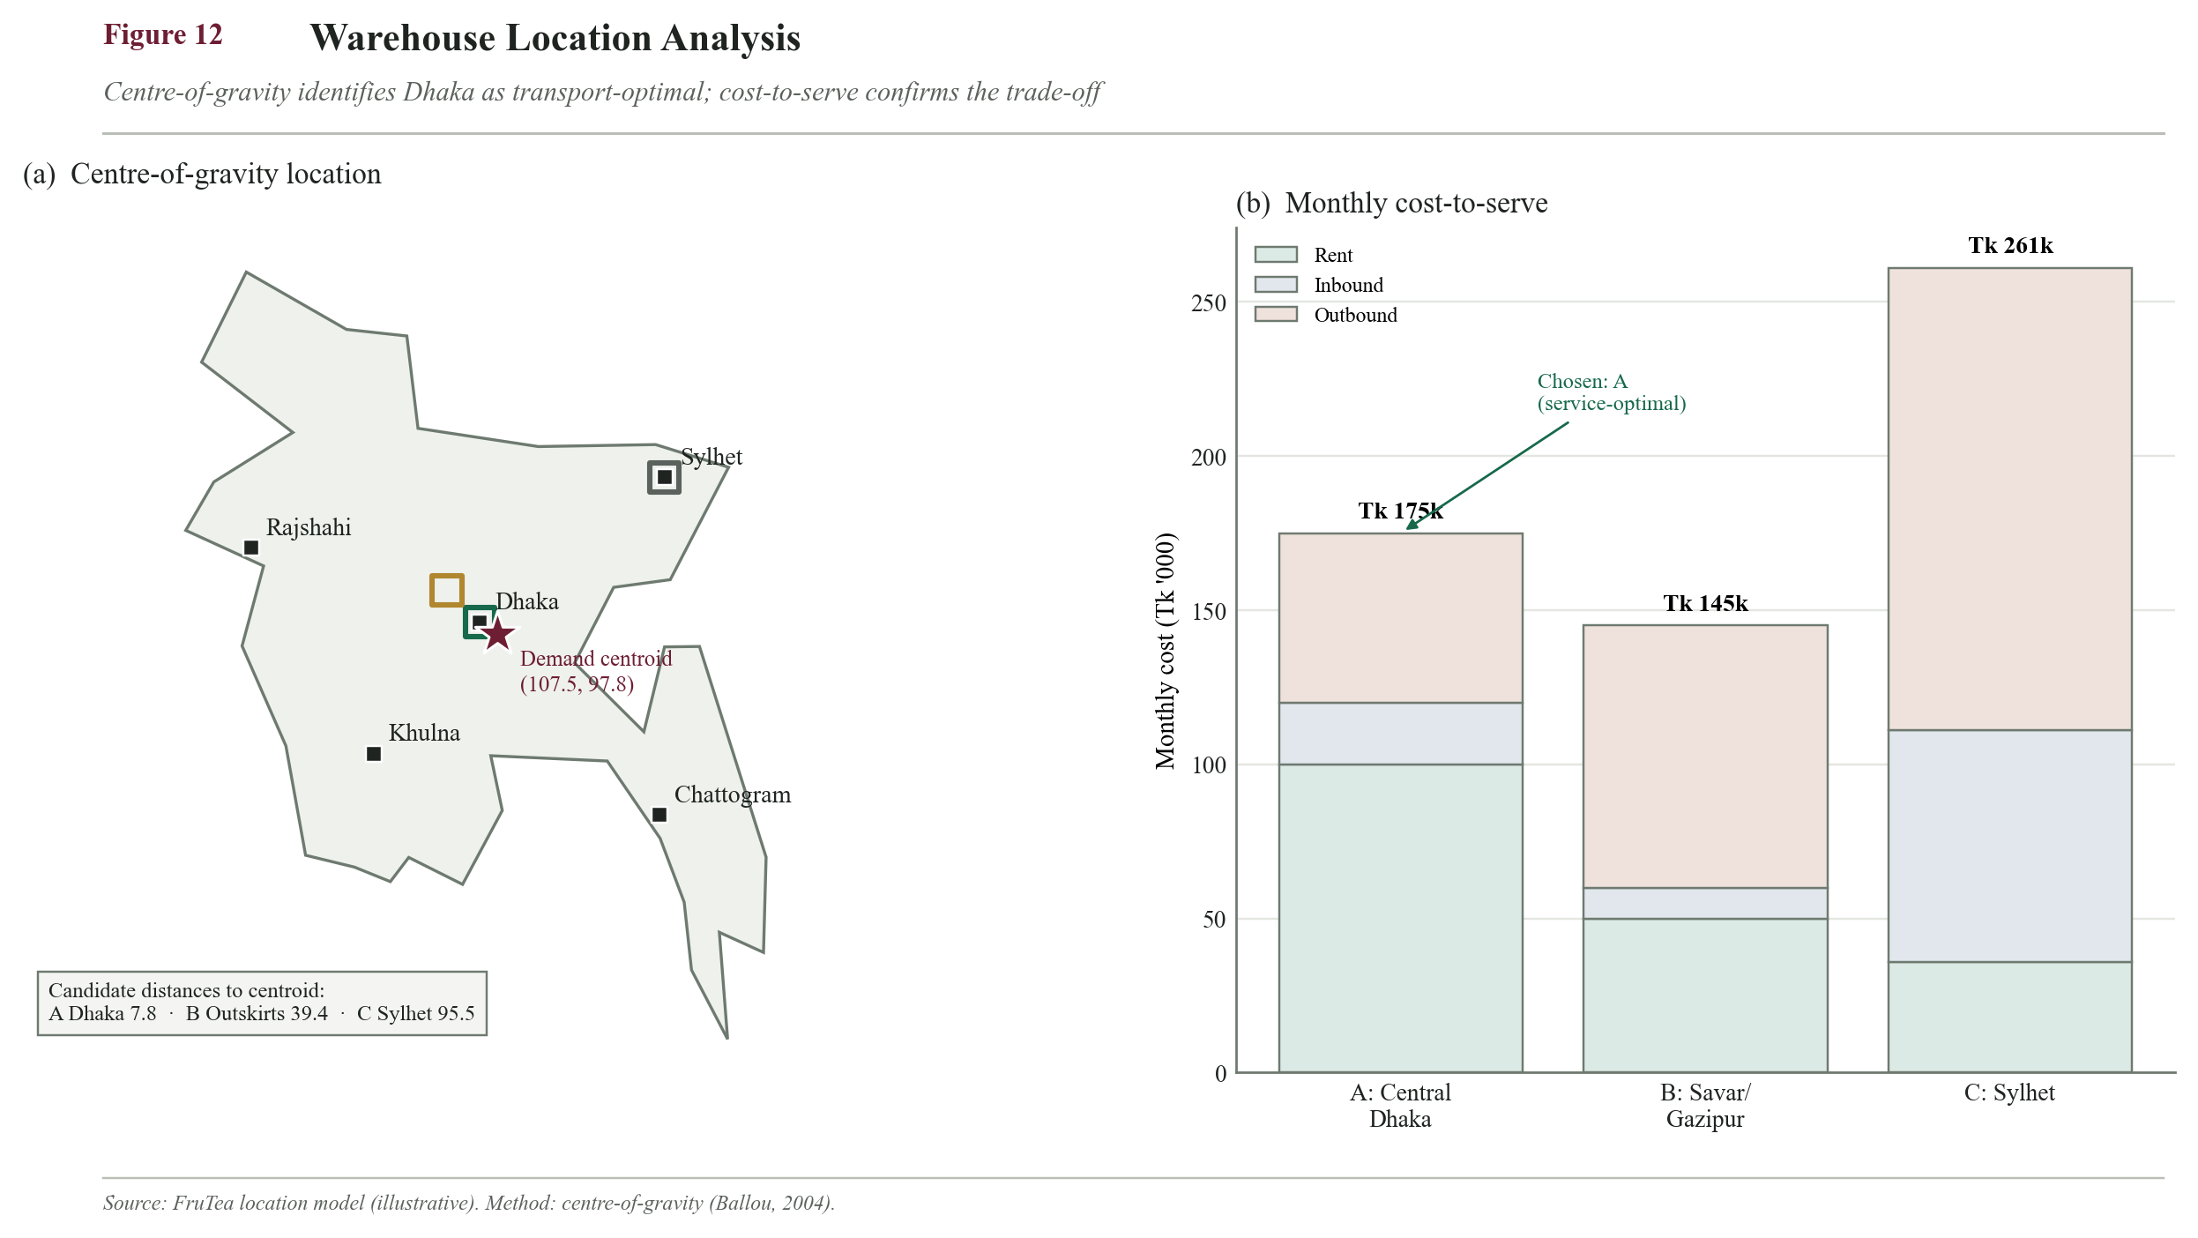
Location map with centroid marker (107.5, 97.8), the three candidates, and a stacked-bar cost comparison

14.2 Facility Specifications, Licensing and Compliance
Operating a packaged-food business in Bangladesh requires specific facility standards and statutory licences. Securing these before launch is a prerequisite for retail and super-shop listing.
Requirement | Authority / standard | Purpose
Trade licence | City Corporation | Legal permission to operate
BSTI product certification | Bangladesh Standards & Testing Institution | Mandatory quality mark for packaged food
Food business licence | Bangladesh Food Safety Authority (BFSA) | Food-safety compliance
TIN & VAT (BIN) registration | National Board of Revenue | Taxation
Import Registration Certificate (IRC) | Office of the CCI&E | Legal import of ingredients
Fire safety licence | Fire Service & Civil Defence | Warehouse fire compliance
Environmental clearance (Yr 2+) | Department of Environment | Required when own manufacturing begins

Facility utilities and provisions: reliable electricity with backup for dehumidifiers, potable water, sanitation and hand-wash stations, pest-proofing, GMP-compliant flooring and lighting, and secure documentation storage.

14.2.1 Regulatory critical path (pre-launch timeline)
Licensing is a gating activity, not a checklist item: retail and super-shop listing legally require the BSTI mark, and BSTI certification is the longest-lead approval. These are therefore started early and run in parallel during the pre-launch window, with BSTI on the critical path.
Approval | Lead time | Start (pre-launch) | On critical path?
Trade licence + TIN/VAT (BIN) | 2-4 weeks | Month -4 | No
Import Registration Certificate (IRC) | 4-8 weeks | Month -4 (before first import) | Gates imports
BFSA food business licence | 4-8 weeks | Month -3 | No (parallel)
BSTI product certification (factory inspection + sample testing) | 8-16 weeks | Month -4 | YES - longest lead, gates retail listing
Fire safety licence | 4-6 weeks | Month -3 | No (parallel)

Implication. BSTI (up to ~4 months) sets the earliest possible retail launch date; the stability study (12.11.3) and IRC run alongside it so nothing else becomes the bottleneck. An investor sees launch timing is governed by a known critical path, not left to chance.
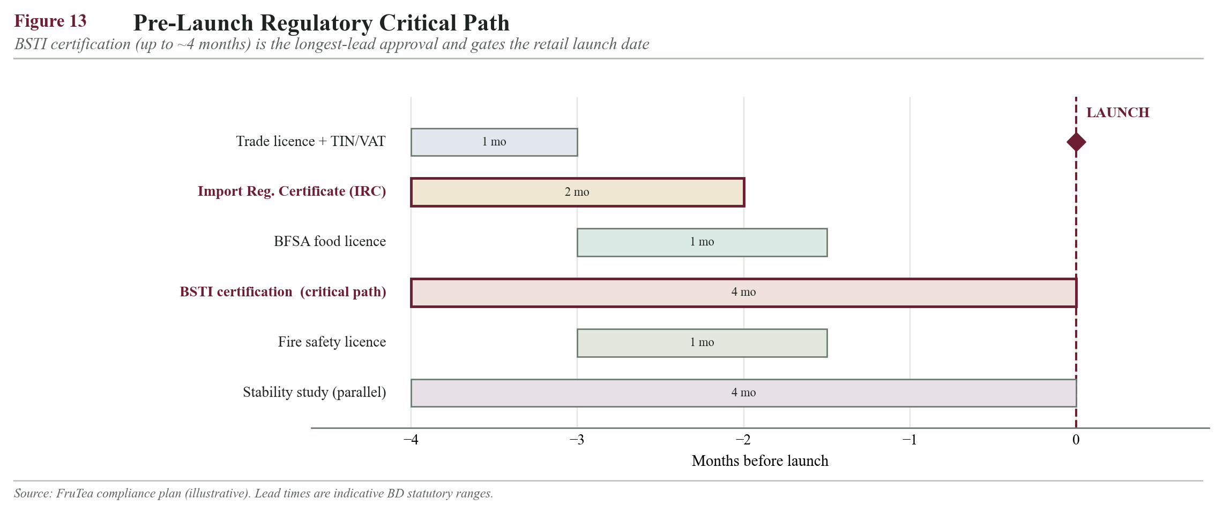
Pre-launch regulatory Gantt chart with BSTI on the critical path

14.3 Daily Operational Activities
Time block | Activities
Morning | Open facility; review overnight online/B2B orders; check stock vs reorder points; goods-inward receiving + QC
Mid-day | Pick/pack/stage orders (FEFO); coordinate distributor & courier pickups; update inventory
Afternoon | Dispatch to channels; handle customer service & B2B calls; process returns/quarantine
End of day | Reconcile dispatch vs orders; update KPI dashboards; place replenishment orders; secure facility
Weekly | Co-packer production booking; supplier ordering; KPI review; cycle-count A-items

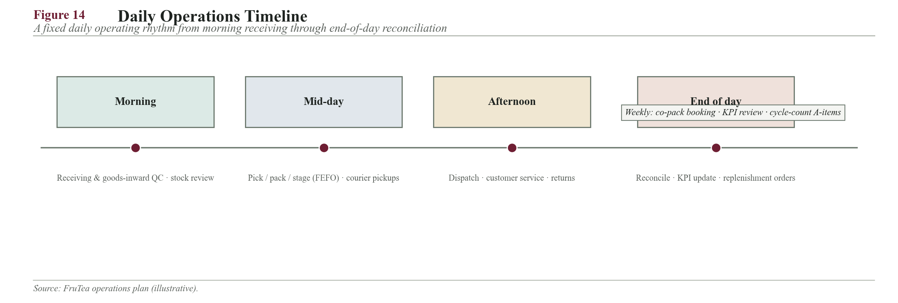
Daily operations activity-cycle timeline

14.4 Order Processing System
Workflow: Order received -> verified & stock-checked -> payment/credit confirmed -> pick (FEFO) -> pack & invoice -> dispatch -> deliver -> confirm & update records.
- B2B/distributor orders via phone, WhatsApp or sales-rep visits, entered into the order system; a daily order cut-off consolidates next-day dispatch.
- E-/F-commerce orders from the website and social shop, fulfilled by courier.
- Payment: B2B on agreed credit terms; retail/online via cash-on-delivery or mobile financial services (bKash/Nagad).
- Dhaka orders target same/next-day fulfilment; regional orders are consolidated for scheduled dispatch, supporting the <=3-day cycle KPI.
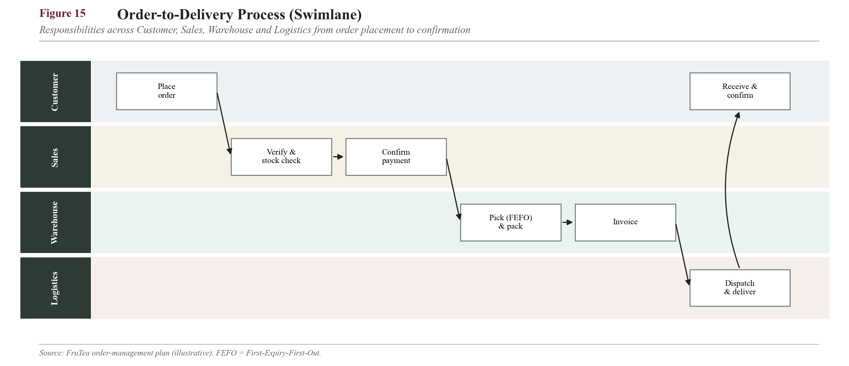
Order-to-delivery swimlane flowchart (Customer / Sales / Warehouse / Logistics lanes)

14.5 Customer Service Plan
- Channels: phone hotline, WhatsApp Business, email and social-media DM — the platforms the young target market already uses.
- B2B care: dedicated key-account handling with reorder reminders for distributors, super shops, cafes and corporates.
- Complaints: logged, acknowledged within 24 hours, and resolved with replacement/refund; the batch code is traced back through QC.
- Feedback is fed into product and quality improvement.
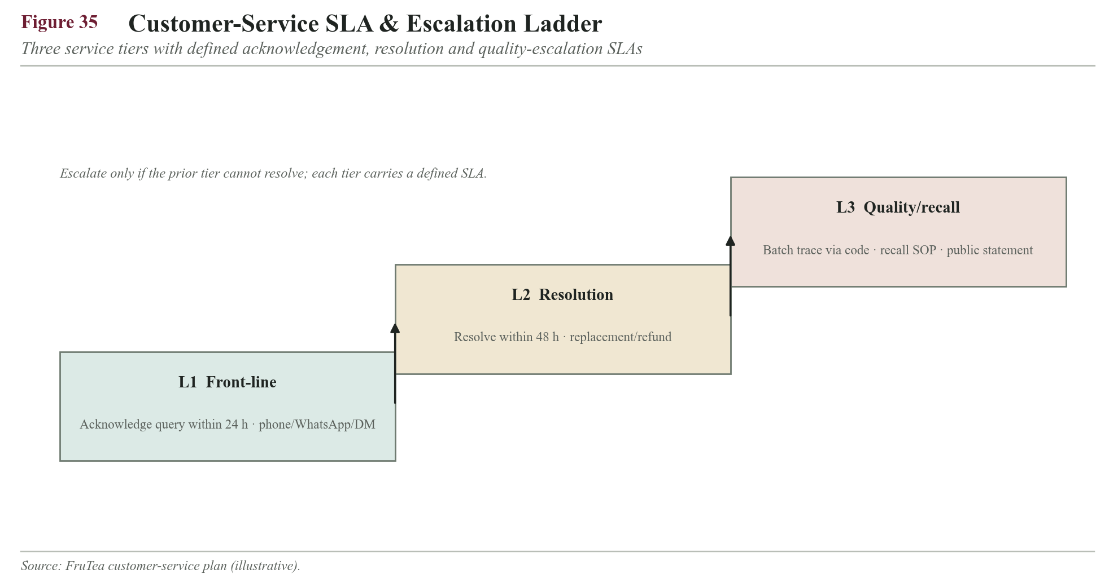
Figure 35. Customer-service SLA and escalation ladder (L1 acknowledge → L2 resolve → L3 quality/recall).

14.6 Technology and Record Keeping
- Inventory & order management: a cloud inventory/POS tool (structured spreadsheets initially) tracking stock, batches, expiry (FEFO) and reorder points.
- Accounting: digital bookkeeping for sales, purchases and cash flow.
- Sales & CRM: distributor/B2B account and reorder tracking.
- E-commerce: the FruTea website plus Facebook/Instagram shop.
- Records retained: batch/production logs, supplier CoAs, QC logs, inventory ledgers, sales/dispatch records and complaint logs — for traceability, audit and food-safety compliance.
- KPI dashboards (12.13 and 14.10) are computed from these systems to drive decisions.
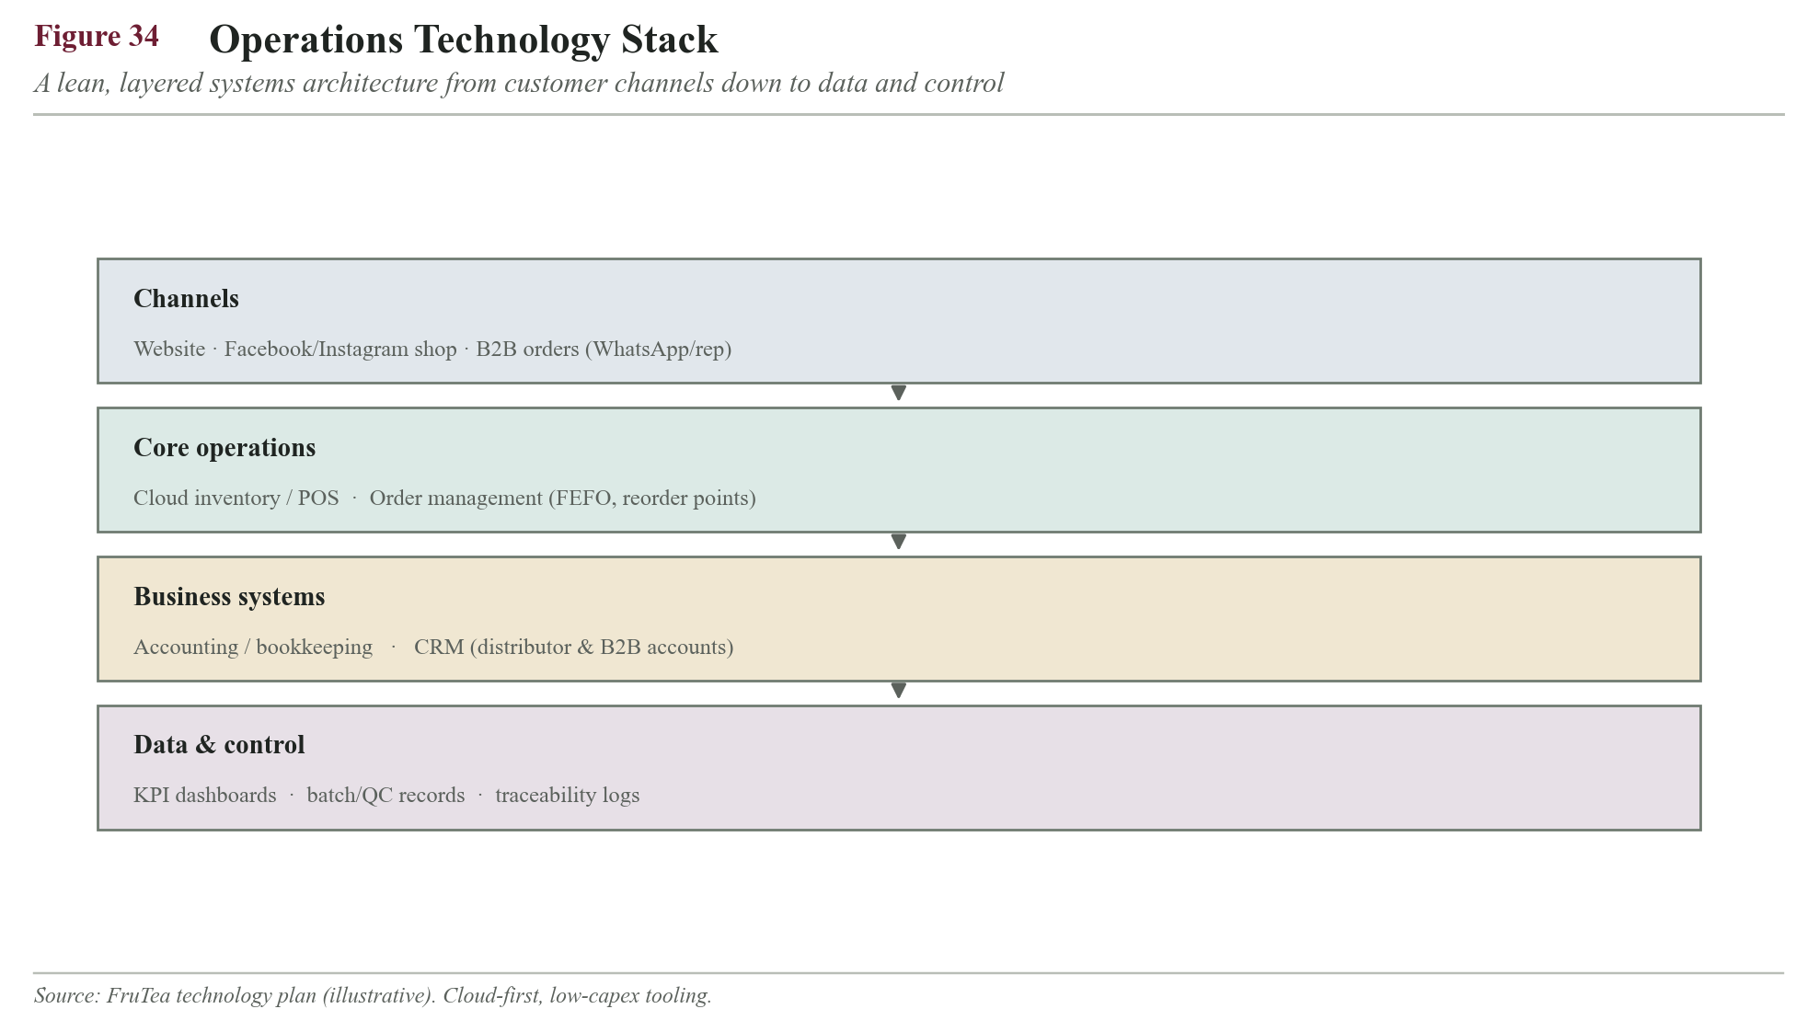
Figure 34. Operations technology stack — a lean, layered architecture from customer channels to data and control.

14.7 Standard Operating Procedures (SOPs)
Consistent, food-safe operations depend on documented SOPs that any staff member can follow, ensuring the product is made and handled identically every time and that the business is audit-ready for BSTI/BFSA inspection. FruTea maintains the following core SOPs:
- Goods Receiving & Inspection SOP — how to verify, sample and accept/reject incoming consignments.
- Storage & FEFO SOP — slotting, stacking, humidity checks and earliest-expiry-first issue.
- Cleaning & Sanitation SOP — GMP cleaning schedules for storage and handling areas.
- Batch Coding & Traceability SOP — code format linking sachet to date/line/lot.
- Order Picking & Dispatch SOP — pick accuracy, packing, invoicing and loading checks.
- Returns & Quarantine SOP — segregation and disposition of returns/damages.
- Product Recall SOP — traceability, withdrawal steps and periodic mock-recall drills.
- Pest Control SOP — baiting, monitoring and record-keeping.
- Customer Complaint Handling SOP — logging, acknowledgement and resolution timelines.
- Health, Hygiene & PPE SOP — staff hygiene and protective equipment rules.

14.8 Health, Safety and Hygiene (GMP)
As a food operation, FruTea applies good manufacturing and hygiene practice: staff hygiene and PPE, sanitised contact surfaces, segregation of raw and finished goods, pest control, and safe storage below 25 C and 60% RH. These practices protect the QC specifications in 12.11 and are a condition of BFSA licensing (Codex Alimentarius Commission, 2020).

14.9 Business Continuity and Contingency Plan
Beyond routine risk mitigation (12.12), FruTea maintains a tiered contingency plan for high-impact disruptions. For each scenario, Solution A is the first response, B the fallback if A is insufficient, and C the last-resort measure to keep the business trading.
Scenario | Solution A (primary) | Solution B (fallback) | Solution C (last resort)
Co-packer shutdown / breakdown | Switch to pre-qualified backup co-packer | Temporarily rent capacity / manual small-batch filling | Fulfil demand from finished-goods buffer; ration to A-SKUs & key accounts
Key import blocked (fruit powder/flavour) | Activate second (dual-source) supplier | Draw down 23-day safety stock while air-freighting a small lot | Temporarily narrow the range to top flavours using in-stock inputs
Demand surge beyond capacity (summer/Eid) | Release pre-built seasonal stock; add co-pack shifts | Prioritise high-margin channels; introduce order caps | Allocate by distributor quota; communicate lead times
Warehouse flooding / fire | Move stock to secondary rented space; invoke insurance | Ship direct from co-packer to key accounts (bypass hub) | Serve online/priority orders only until restored
Sharp forex / sugar price shock | Absorb via price buffer; renegotiate contracts | Adjust pack sizes/pricing; increase local substitution | Temporary MRP revision with channel communication
Quality issue / recall | Execute recall SOP; isolate the batch by code | Replace affected stock; root-cause with supplier | Pause the affected SKU; public quality statement
Transport strike / hartal / floods | Switch among multiple 3PL carriers | Use distributor local buffers; reschedule routes | Offer pickup / delay non-urgent deliveries
Power outage (humidity control) | Backup generator for dehumidifiers | Shift stock to climate-stable zone; seal pallets | Expedite dispatch of at-risk stock to reduce exposure

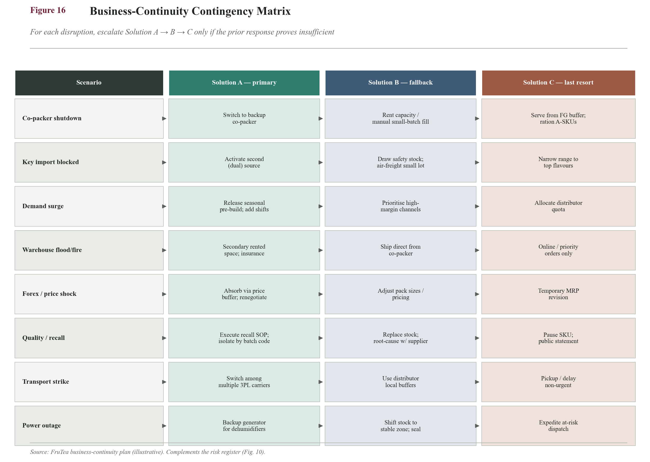
Business-continuity decision tree / contingency escalation flow (A -> B -> C)

14.9a Operational Drivers of Working Capital (inputs for Finance)
Cash tied up in the chain is driven by operational timing. This plan owns and optimises the day-count drivers below; the resulting taka funding requirement is calculated by the Finance section. Reducing any of these days directly frees cash.
Driver | Days | Operational lever to reduce it
Days Inventory Outstanding (DIO) | ~39-49 days | Third fruit-powder source / shorter import lead time (12.6.4)
Days Sales Outstanding (DSO, B2B credit) | ~15-30 days | Tighter credit terms; MFS/COD on smaller accounts
Days Payable Outstanding (DPO, supplier terms) | ~30 days (target) | Negotiate credit terms with local suppliers
Cash Conversion Cycle (CCC = DIO + DSO - DPO) | ~24-39 days | Net effect of the above

Note. These operational days are the inputs the Finance team needs to size working-capital funding; the monetary figure and financing structure sit in that section, not here.

14.10 Operational KPIs
KPI | Definition | Target
Order accuracy | % orders error-free | ≥98%
On-time delivery | % within promised window | ≥95%
Order fulfilment cycle | order-to-dispatch time | ≤24 hrs (Dhaka)
Warehouse utilisation | % usable storage used | 70-85%
Inventory accuracy | system vs physical | ≥98%
Complaint resolution time | avg. time to resolve | ≤48 hrs
Return/damage rate | % returned/damaged | ≤1%
Cost per order fulfilled | total ops cost / orders | tracked, reduced YoY

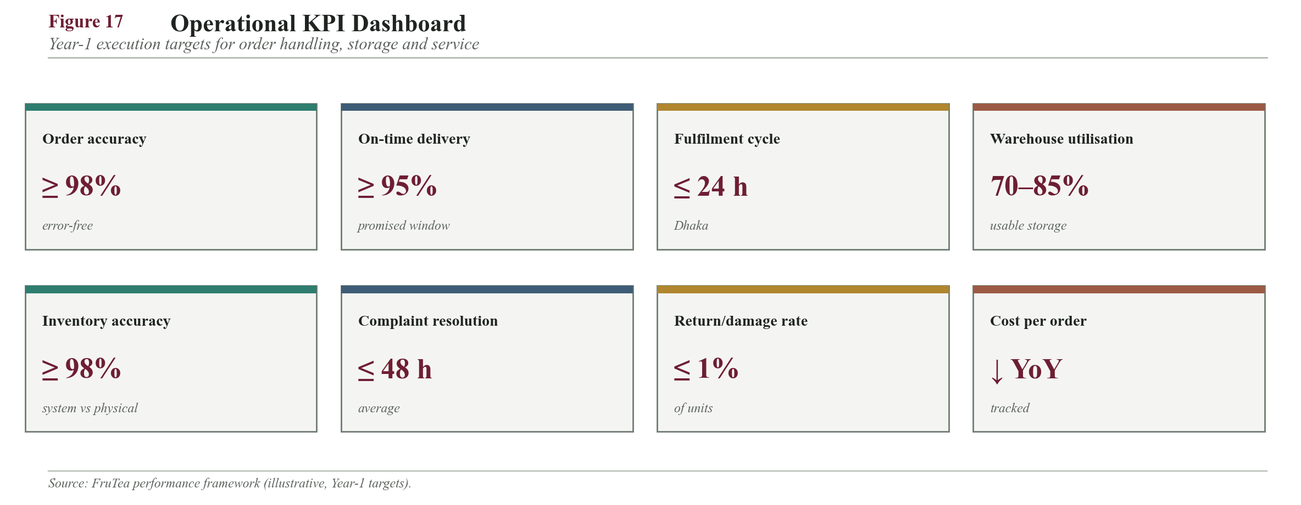
Operational KPI dashboard tiles

References (APA 7th)
Note: the following academic and industry sources informed the methods, formulas and benchmark figures used in Sections 12 and 14. Market and price values are illustrative planning assumptions and should be verified against current figures before final submission.
Ballou, R. H. (2004). Business logistics/supply chain management: Planning, organizing, and controlling the supply chain (5th ed.). Pearson/Prentice Hall.
Bangladesh Bank. (2023). Annual report 2022-2023. Bangladesh Bank. https://www.bb.org.bd
Bangladesh Tea Board. (2022). Tea statistics of Bangladesh. Bangladesh Tea Board. http://www.teaboard.gov.bd
Chopra, S., & Meindl, P. (2019). Supply chain management: Strategy, planning, and operation (7th ed.). Pearson.
Codex Alimentarius Commission. (2020). General principles of food hygiene (CXC 1-1969) and HACCP guidelines. Food and Agriculture Organization & World Health Organization.
Heizer, J., Render, B., & Munson, C. (2020). Operations management: Sustainability and supply chain management (13th ed.). Pearson.
Jacobs, F. R., & Chase, R. B. (2021). Operations and supply chain management (16th ed.). McGraw-Hill Education.
Kraljic, P. (1983). Purchasing must become supply management. Harvard Business Review, 61(5), 109-117.
Mordor Intelligence. (2023). Ready-to-drink (RTD) tea market: Growth, trends, and forecasts. Mordor Intelligence.
Slack, N., Brandon-Jones, A., & Burgess, N. (2019). Operations management (9th ed.). Pearson.
Statista. (2023). Tea market in Bangladesh and global instant/RTD tea segment. Statista. https://www.statista.com

End of Sections 12 & 14 (Mahera), Version 7. All monetary and market figures are illustrative planning assumptions benchmarked from comparable instant-beverage and Bangladeshi FMCG operations; reconcile with the Finance section before final submission. Visuals to be inserted at the marked [VISUAL] points after content approval.

